|  |
| --- |
|  |
| **C:\CERT\GreatWrittenCommunication\zOldStuffDoNotUse\ofgemelecsig.gif** |
|  |
|  |
| D-4.1.5 E2E Solution Architecture  Ofgem Switching Programme |
|  |

|  |  |  |  |  |  |
| --- | --- | --- | --- | --- | --- |
|  |  |  |  |  |  |
| **Author(s):** | Ofgem |  |  | **Team:** | Switching Design Team |
| **Publication date:** | 03 June 2019 |  |  | **Email:** | SwitchingPMO@ofgem.gov.uk |
| **Version:** | 2.2 |  |  |  |  |
|  |  |  |  |  |  |

|  |
| --- |
|  |

**Overview:**

This document describes the logical architecture of the new Switching Arrangements. It identifies changes that will need to be made by Market Participants and Central Data Service Operators in order to support the new arrangements and describes the interactions between these organisations and the Central Switching System (CSS). The changes are summarised and ordered to aid reference by each organisation. It classifies each interaction, using a defined set of logical patterns.

*This document provides illustrative information on how central systems will operate. These requirements may be updated as the design progresses from the logical to the physical level. In particular, updates may be required as a result of procurement of the CSS as well as development of the changes needed to other central data services, such as UK Link and MPAS, which are being progressed under the UNC and MRA.*

Associated Documents

|  |  |  |
| --- | --- | --- |
| Ref. | Document Title or Name | Version / Date |
| [1] | D-1.1 Architectural Principles | TDA paper 20/03/2017 |
| [2] | D-4.1.2 E2E Detailed Design Model (ABACUS Switching Design Repository)  Note that this product also fulfils D-4.1.3 Data Architecture and Data Governance | V4.1  30/05/2019 |
| [3] | D-4.1.4 E2E Switching Arrangements NFR | 22/06/2018 |
| [4] | D-4.1.6 E2E Operational Choreography | 30/11/2018 |
| [5] | D-4.1.9 E2E Switching Service Management Strategy | 12/02/2018 |
| [6] | D-4.1.10.1 E2E Security Architecture | 12/02/2018 |
| [7] | D- 4.1 – DB3 E2E Design Assumptions | 12/02/2018 |

Version control

|  |  |  |
| --- | --- | --- |
| **Revision Date** | **Version** | **Summary of changes** |
| 15/02/2018 | V1.0 | Published for DB3. |
| 22/06/2018 | V2.0 | Published for DB4. Incorporates minor amendments agreed in Change Request CR007, CR008, CR009 and CR012. |
| 30/11/2018 | V2.1 | Changes for CR-E08 and CR-E12 |
| 23/04/2019 | V2.2 | Change request CR-E33 |

Contents

1. Executive Summary 5

2. Introduction 6

Objective 6

Scope 6

3. Considerations and Impacts on Existing Participants 7

Introduction 7

Central Data Services 12

Meter Point Administration Service (MPAS) 12

UK Link 14

Smart Metering 16

Data Enquiry Service (DES) 18

Electricity Central Online Enquiry Service (ECOES) 20

Suppliers and Shippers 22

Supplier (Gaining and Losing) Data Service 22

Shipper Data Service 25

Agents 27

Data Collectors (DC) 27

Data Aggregators 29

MEMs 30

Other Participants 31

DNOs 31

Gas Transporter Data Service 32

MAPs 33

Settlements 35

Third Party Intermediaries (TPI) 36

Other Agents 37

Switching Domain Data Services 37

4. General Architectural Considerations 40

Switching Network 40

Data Services Architecture 40

Data Model 41

Data Services Landscape 41

Interfaces 42

Configurable Functionality 43

Interface Patterns 44

Interface Operation and Processing 48

5. CSS and Address Service Architecture 53

CSS Inbound Interfaces 53

CSS Outbound Interfaces 54

CSS Functional Architecture 56

CSS and Address Service 57

Appendix 1 – Glossary 59

Appendix 2 – Use of Switching Design Repository 60

Appendix 3 – Structure of the DES Service 60

1. Executive Summary
   1. This document belongs to the set describing the end-to-end behaviour of the new Switching Arrangements. The document’s purpose is to describe the architecture of the new Switching Arrangements, by:

* Identifying the constituent elements of the Switching Arrangements, including all new and existing data services and their interfaces;
* Providing details on the interfaces between CSS and the Market Participants and between CSS and other Central Data Services;
* Describing the features of the new Switching Arrangements that will need to be implemented by service providers (both new and existing); and
* Describing at a logical level the types of interfaces between CSS and other data services (the “interface patterns”) and the characteristics of each type.
  1. The document will be used by all organisations participating in the new Switching Arrangements to gain a high-level understanding of the changes that their service provider(s) will need to make. Where an interaction is between CSS and another participant, then details are given in this document to enable understanding of the scope of the change that will be needed. Further details will be made available as the Switching Programme progresses. Where an interaction is between two organisations neither of which is CSS, then this document does no more than identify the interaction. The organisations involved are expected to conduct their own impact analysis and channel comments back through the Programme Design Forum. The arrangements will ultimately be taken forward by the regulatory design group for implementation into licences and codes.

1. Introduction

## Objective

* 1. This document describes at a high level the logical architecture of the new Switching Arrangements, to inform the design of enhancements that participating organisations will need to make.

## Scope

* 1. The data services included in this document are all of those that will participate in the new Switching Arrangements and the interfaces between them. More detailed information is provided where those interfaces interact with CSS than for those where CSS is not involved.
  2. The new Switching Arrangements, are summarised in Figure 1 - E2E Switching Data Services Landscape.
  3. The architecture presented in this document is intended to be sufficiently generic not to constrain the technical approach eventually selected for CSS, such that innovative solutions may be considered where appropriate.
  4. The document contains sections which describe:
* The impact on each participant (both Market Participants and Central Data Services);
* The new interfaces that will be necessary;
* Introductory information regarding the ABACUS Data Model;
* Interface Patterns (the four different types of interface) for those interfaces between CSS and participants;
* All of the ABACUS processes and the Market Participant/Central Data Service implicated in each; and
* A summary of the logical architecture of CSS.

1. Considerations and Impacts on Existing Participants

## Introduction

* 1. The new End-to-End (E2E) Switching Arrangements will be based around a new CSS, which will support a revised set of switching business processes, harmonising the arrangements across gas and electricity and delivering a faster, more efficient and more reliable switching process to consumers. The CSS will be procured as a service, which will comprise design, build, test and operate. The CSS solution may be procured from one or from many service providers. Since the procurement structure is not yet known, the components have been expressed in this document in functional terms, as:
* **CSS Registration Service**, which manages the gas and electricity registrations and addresses associated with them;
* **Address Service** manages a complete list of GB standardised addresses and performs address matching; and
* **Switching Network** connects CSS Registration Service to the other Switching Arrangements participants; in practice the requirements for this are likely to be fulfilled by use of DTN and iXN.
  1. NOTE THAT ”CSS” in the rest of this document means CSS Registration Service; if “overall CSS solution” is meant, then this is stated explicitly.
  2. The Switching E2E product set, of which this document is part, has been produced in order to document the way the new arrangements will work across the electricity and gas industries as a whole. Apart from forming the basis on which further, more detailed design work can be undertaken on the overall CSS solution, these documents are for use by existing industry participants, both by Central Data Service suppliers (such as xoserve, who provide UK Link) and Market Participants, such as suppliers, in order to begin the process of defining and assessing the changes they will need to make to their systems in order to take part in the new arrangements.
  3. The sections that follow document these impacts at a high level, taking each existing participant in turn. The information provided here is supported by further detail in D-4.1.2 E2E Detailed Design Model held in the CASE tool ABACUS - see D-4.1.2 - Detailed Design Models[2]. An organisation wishing to understand the full details will need to invest time in understanding this model.
  4. The sections describing the impacts have been ordered as follows:
* Central Data Services;
* Market Participants;
* Agents; and
* Other Participants.
  1. Following this are some general architectural concepts which are important to understand in order to assimilate the information in the ABACUS model and to understand the way in which the interfaces with CSS will work.
  2. Full impact assessment ‎will require analysis of this document in combination with:
* D-4.1.2 - Detailed Design Models[2] – including E2E Business Processes, Interaction Sequence Diagrams, Logical Data Model and Interface Specifications
* D-4.1.4 – Non-Functional Requirements[3]
* D-4.1.6 - Operational Choreography[4]
* D-4.1 – DB3 E2E Design Assumptions[7]
* MRASCo Data Transfer Catalogue for existing interfaces between parties defined in the As-Is Electricity switching arrangements
* SPAA RGMA Data Transfer Catalogue for existing interfaces between parties defined in the As-Is Gas switching arrangements
* The UK LINK MANUAL STANDARDS GUIDE. July 2017, Version 16 for interfaces between UK Link and Shippers Third Parties’ existing technical and operational documentation as required
  1. Service Management and Operations related services and interfaces are not covered in this document. For more information, please refer to D-4.1.9 E2E Switching Service Management Strategy[5].



Figure 1 - E2E Switching Data Services Landscape

* 1. Note the following conventions which are used for all UML type diagrams in this document:



Figure 2 – Interface Notation Conventions

* 1. While the Data Enquiry Service (DES) is represented as a single logical system in Figure 1 above, the physical implementation is based on a SAP Business Warehouse application. Further details of the implementation are included in Appendix 3 – Structure of the DES Service.
  2. The following table gives a brief description of each of the data services outlined in Figure 1 - E2E Switching Data Services Landscape that is within scope of the E2E architecture for CSS, and their role in the Switching Arrangements. Subsequent sections provide an analysis of the impact that the new solution will have on these data services.

|  |  |  |
| --- | --- | --- |
| Data Services | Gas or Electricity | Role in Switching Process |
| MIS TPIs  e.g. Price Comparison Websites (PCW), Brokers | Both | Third Party Intermediary(ies), allows (all) consumers to search and compare supplier tariffs. Prefix “MIS” refers to the “Market Intelligence Service” aspect of the switching arrangements that is fulfilled by TPIs. |
| Supplier (Gaining) | Both | Agrees contract with new consumer. Carries out pre-switch validation and issues Switch Request. May choose to withdraw switch requests or deactivate active registrations. |
| Supplier (Losing) | Both | Responds to invitation to object and may raise annulment, initiates consumer contract termination processes. |
| Smart Metering Data Service[1] | Both | Manages the transfer of service requests and data between users and Smart Meters. |
| MPAS (MPAS) | Electricity | Service maintaining multiple databases of meter points. Each DNO is acting in the capacity as the provider of MPAS for Metering Points in its Distribution System. Processes switching related data flows. |
| UK Link | Gas | Service maintaining a database of supply meter point and registration data. Processes switching related data flows. |
| CSS | Both | Core of the switching process, orchestrating all switching process flows and maintaining the authoritative source of meter point registration data. |
| Address Service | Both | Third Party service supplying GB standardised address data and facilities to match addresses against it. |
| Gas Transporter | Gas | Is responsible for physical works relating to creation, termination and capping of Supply Meter Points. |
| Switching Domain Data Service[2] | Both | Responsible for the capture and maintenance of user and parameter data needed for the operation of the Switching Arrangements. |
| Gas Shipper | Gas | Responsible for agreeing settlement parameters with the (Energy) Supplier, updates some details (such as asset details) in UK Link on behalf of the Energy Supplier and receives notifications from CSS at Validated, Confirmed and Secured switch states. |
| Distribution Network Operator (DNO) | Electricity | Processes meter point creation and terminations. |
| ECOES | Electricity | Enquiry service. National database of electricity meter point and associated data. |
| Data Enquiry Service (DES) | Gas | Enquiry service. National database of gas supply meter point and associated data. |
| Meter Asset Provider (MAP) | Both | Provides meter asset and receives notifications on Secured Switches |
| Metering Equipment Manager (MEM) | Both | Initiates replacement or removal of metering assets and receives notifications on Confirmed and Secured Switch states. |
| Data Aggregator (DA) | Electricity | Receives notification of Confirmed and Secured Switches. |
| Data Collector (DC) | Electricity | Processes and validates electricity switch reads and receives notification of Confirmed and Secured Switches |

## Central Data Services

### Meter Point Administration Service (MPAS)

* 1. MPAS is a Data Service operated by DNOs to record data about metering points. Each MPAS requires impact assessment of the changes introduced by the To-Be arrangements.
  2. MPAS will undergo a series of changes related to the process of switching electricity supplier, updating meter asset details, maintaining meter point data, including:
* Management of the Switching Process and Initial Registration (of RMP to Energy Supplier) will be transferred to CSS from MPAS. This process transfer will be done in a manner that will not impact the remaining core functionality of MPAS. This change will be supported by the introduction of new interfaces between MPAS and other services.
* Provision of Registration Data Provider (RDP) information (currently supplied by MPAS to the DCC) will be transferred to the CSS. Note that the reverse feed of data from DCC to MPAS will stay as is.
* Management of RMP will remain with MPAS, but additions / changes will need to be made to support E2E Switching:
  + Identification and maintenance of Meter asset data (including MAP), will be transferred from ECOES to MPAS. This data will be provided by MEMs to MPAS by means of existing interfaces, which may be achieved by an indirect route via the existing Shipper interfaces.
  + The ‘Primary’ asset at each RMP will be identified and maintained.
  + The MAP for the ‘Primary’ asset will be included in Metering Point Status updates to CSS through the MeteringPointSync interface and will be maintained in MPAS.
  + The Retail Offering (Import or Export) will be identified for each RMP – once set this indicator cannot be changed.
  + On request, MPAS will create RMPs for premises situated on Licence Exempt Networks that are within their distribution areas. These will be coded with a Licence Exempt Network Indicator.
  + Identification and maintenance of Related RMPs (previously Related MPANs), to include an explicit association, so that ‘Child’ RMPs can be identified for each ‘Parent’ and vice versa. Also, the ‘role’ for each RMP in the association must be designated as either ‘Parent’ or ‘Child’ (only one ‘Parent’ is allowed per association).
  + Inclusion of RMP status and management of the (logical) values as the RMP advances through its lifecycle. These values must be included in the interfaces.
  + Retail Energy Location Updates will be passed from CSS to MPAS.
  1. New interfaces between MPAS and CSS are required to facilitate the wider E2E Switching Arrangements. CSS will have the capability to process both inbound and outbound requests as defined in the Interfaces section of this document. Interfaces will employ messaging (buffered).
  2. Interfaces will provide CSS from MPAS with a daily full update feed of data that represents electricity meter point information, the identity of the primary asset Meter Asset Provider (MAP) and the Metering Equipment Managers (MEM), Data Collector (DC) and Data Aggregator (DA) appointments.
  3. The new industry business processes, business rules and interaction sequence diagrams involving MPAS and its involvement in these processes, are defined in the Switching Design Repository (ABACUS).

#### Impact Summary

* 1. The following table provides a summary of the new CSS (including Switching Domain Data Service) interfaces that are specified for MPAS in ABACUS, plus two interfaces that are not in ABACUS but are referenced for completeness:

|  |  |  |  |
| --- | --- | --- | --- |
| Interface Name | Directionality | Sending Data Service | Receiving Data Service |
| DADCAppointment | Outbound | MPAS | CSS |
| MEMAppointment | Outbound | MPAS | CSS |
| MeteringPointSync | Outbound | MPAS | CSS |
| RegistrationSync | Inbound | CSS | MPAS |
| MeteringPointStatus | Inbound | DNOs | MPAS |
| ElectricityRetailMarketData | Outbound | MPAS | ECOES |
| SwitchingDomainData[3] | Inbound | Switching Domain Data Service | MPAS |
| RetailEnergyLocation | Inbound | CSS | MPAS |

* 1. Note: MeteringPointStatus is an existing interface between MPAS and DNO Data Service. It is included here for completeness. Any changes necessary as a result of the new Switching Arrangements will need to be agreed between the respective Service Owners.
  2. Note: ElectricityRetailMarketData is an existing interface between ECOES and MPAS. It is included here for completeness. Any changes necessary as a result of the new Switching Arrangements will need to be agreed between the respective Service Owners.
  3. These interfaces are shown in the next diagram:



Figure 3 – New/Changed Interfaces with MPAS

### UK Link

* 1. UK Link will undergo a series of changes related to the process of switching gas supplier, updating supply meter point asset details, and maintaining meter point data, including:
* Management of the Switching Process and Initial Registration (of RMP to Energy Supplier) will be transferred to the CSS service from UK Link. This process transfer will be done in a manner that will not impact the remaining core functionality of UK Link and will require the creation of a number of new interfaces between CSS and UK Link.
* Responsibility for the Switching Process and Initial Registration will be transferred from Shippers to Suppliers, but Shippers will continue to interact with UK Link to update settlement parameters.
* Provision of Registration Data Provider (RDP) information (currently supplied by UK Link to the DCC) will be transferred to the CSS. Note that the reverse feed of data from DCC to UK Link will stay as is.
* Management of RMP (including details of installed assets) will remain with UK Link, but additions and changes will need to be made to support E2E Switching:
  + Metering Asset Managers (MAMs) will be split into Metering Equipment Managers (MEMs) and Metering Asset Providers (MAPs). UK Link will be updated to hold the two roles separately for each asset.
  + The ‘Primary’ asset at each RMP will be identified and maintained. This data will be provided by MEMs to UK Link by means of existing interfaces, which may be achieved by an indirect route via the existing Supplier/Shipper interfaces.
  + The MAP for the ‘Primary’ asset will be included in Supply Meter Point Status updates to CSS.
  + On request, UK LINK will create RMPs for premises situated on Licence Exempt Networks (LENs) that are within their distribution areas. These will be coded with a Licence Exempt Network Indicator.
  + Inclusion of RMP status and management of the (logical) values as the RMP advances through its lifecycle. These values must be included in the interfaces.
  + Retail Energy Location Updates will be passed from CSS to UK Link.
  1. An interface from UK Link to CSS will provide a full update feed of data that represents gas meter point information that includes supplier registration data. It will also provide identity of the primary asset Meter Asset Provider (MAP), which will be maintained in UK Link, and the Metering Equipment Managers (MEM).
  2. New interfaces between UK Link and CSS are required to facilitate the wider E2E Switching Arrangements. CSS will have the capability to process both inbound and outbound requests as defined in the Interfaces section of this document.
  3. The new industry business processes and business rules involving UK Link Provider, and interaction sequence diagrams describing its involvement in these processes, are defined in the Switching Design Repository (ABACUS).

#### Impact Summary

* 1. The following table provides a summary of the new CSS (including Switching Domain Data Service) interfaces for UK Link in ABACUS, plus two interfaces that are not in ABACUS but are referenced for completeness:

|  |  |  |  |
| --- | --- | --- | --- |
| Interface Name | Directionality | Sending Data Service | Receiving Data Service |
| MEMAppointment | Outbound | UK Link | CSS |
| SupplyMeterPointSync | Outbound | UK Link | CSS |
| RegistrationSync | Inbound | CSS | UK Link |
| SupplyMeterPointStatus | Inbound | Gas Transporters Data Service | UK Link |
| GasRetailMarketData | Outbound | UK Link | DES |
| SwitchingDomainData[4] | Inbound | Switching Domain Data Service | UK Link |
| RetailEnergyLocation | Inbound | CSS | UK Link |

* 1. Note: SupplyPointMeterStatus is an existing interface between the Gas Transporters (GT) Data Service and UK Link. It is included here for completeness. Any changes necessary as a result of the new Switching Arrangements will need to be agreed between the respective Service Owners.
  2. Note: GasRetailMarketData is an existing interface between UK Link and DES. It is included here for completeness. Any changes necessary as a result of the new Switching Arrangements will need to be agreed between the respective Service Owners.
  3. The new interfaces are shown in the next diagram:



Figure 4 – New/Changed Interfaces with UK Link

### Smart Metering

* 1. RDP (Registration Data Provider) data from Gas and Electricity will be provided in one single interface from CSS. CSS will assume responsibility for providing RDP updates to the Smart Metering Data Service via the RMPRegApptSync interface. These updates currently occur directly between the Electricity and UK Links and the Smart Metering Data Service.
  2. The current Registration Service Interfaces for Gas and Electricity[5] into Smart Metering will be combined into a single interface with a similar data format of the existing combined file formats of the current interface specification – aligned to the Data Model and Interface standards defined in D-4.1.2 - Detailed Design Models[2] and D-4.1.10.1 E2E Security Architecture[6]. Note that the interfaces from Smart Metering outward to UK Link and MPAS will continue, but that this will be reviewed to ensure that Users do not bear unwarranted costs of maintaining a Gamma connection.
  3. To support improvements in quality of Addresses, the Smart Metering Data Service will interface to CSS providing details of Communications Hub to meter connection information (showing which meter points are at a single premises).
  4. The Smart Metering Data Service will be required to support Messaging interfaces with CSS as defined in the Interfaces section of this document.

#### Impact Summary

* 1. The following table provides a summary of the new CSS (including Switching Domain Data Service) interfaces that are specified for the Smart Metering Data Service in ABACUS:

|  |  |  |  |
| --- | --- | --- | --- |
| Interface Name | Directionality | Sending Data Service | Receiving Data Service |
| RMPRegApptSync | Inbound | CSS | Smart Metering Data Service |
| CommsHubDataLink | Outbound | Smart Metering Data Service | CSS |
| REGIS | Outbound | Smart Metering Data Service | UK Link |
| REGIS | Outbound | Smart Metering Data Service | MPAS |
| SwitchingDomainData[6] | Inbound | Switching Domain Data Service | Smart Metering Data Service |

* 1. These interfaces are shown in the next diagram:

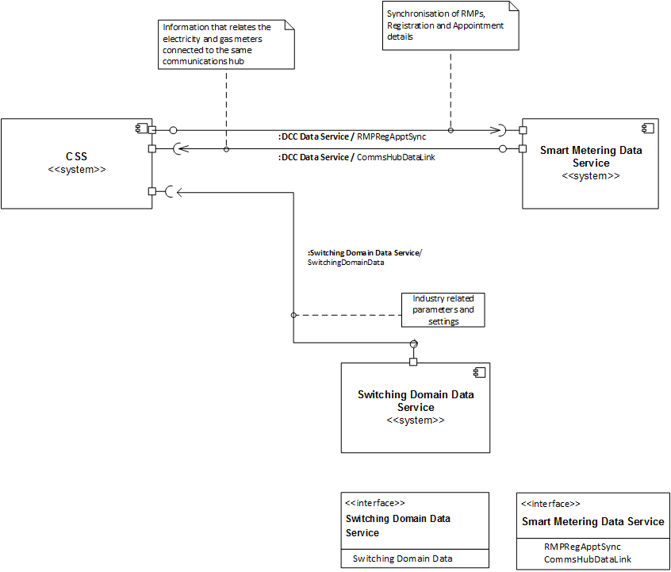

Figure 5 – New/Changed Interfaces to the Smart Metering Data Service

### Data Enquiry Service (DES)

* 1. To reflect the CSS updates in DES and in other data provision services e.g. Application Programme Interface (API) services to Price Comparison Websites, the CSS updates will come into the SAP Business Warehouse (BW) service and from there will be available for the relevant data provision services. This information is included here for completeness. Any changes necessary as a result of the new Switching Arrangements will need to be defined by Xoserve.
  2. DES will undergo changes related to receiving new gas enquiry information related to switched gas registrations (i.e. switched gas supplier and shipper). This new enquiry information will include the REL Address for a given RMP, transferred via a new interface from CSS to DES. Note that this does not affect the flow of the Meter Point Location Address from UK Link to DES, which continues unchanged. Both MEM and MAP data will need to be held in DES.
  3. Registration information synchronised to DES will include the Erroneous Switch Indicator, and the valid Registration states in CSS. Access to this information may be restricted using the Role Based Access Control arrangements provided by DES.
  4. The new industry business processes and interaction sequence diagrams involving DES and its involvement in these processes, are defined in the Switching Design Repository (ABACUS).

#### Impact Summary

* 1. The following table provides a summary of the new CSS (including Switching Domain Data Service) interfaces that are specified for DES in ABACUS, plus two interfaces that are not in ABACUS but are referenced for completeness:

|  |  |  |  |
| --- | --- | --- | --- |
| Interface Name | Directionality | Sending Data Service | Receiving Data Service |
| RetailEnergyLocation | Inbound | CSS | DES |
| GasRegistration | Inbound | CSS | DES |
| TPIGasEnquiry | Inbound | MIS TPI Data Service | DES |
| GasRetailMarketData | Inbound | UK Link | DES |
| SwitchingDomainData[7] | Inbound | Switching Domain Data Service | DES |

* 1. Note: TPIGasEnquiry is an existing enquiry interface between MIS TPI Data Services and DES. It is included here for completeness. Any changes necessary as a result of the new Switching Arrangements will need to be agreed directly between the respective Service Owners.
  2. Note: GasRetailMarketData is an existing interface between UK Link and DES. It is included here for completeness. Any changes necessary as a result of the new Switching Arrangements will need to be agreed directly between the respective Service Owners.
  3. These interfaces are shown in the next diagram:

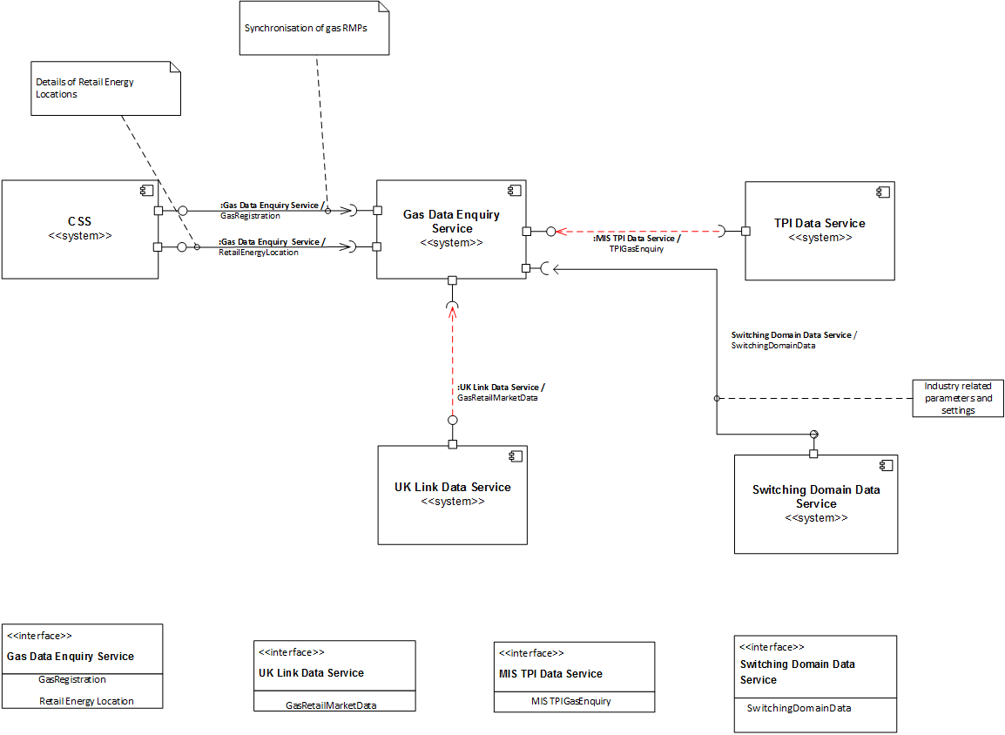

Figure 6 – New/Changed Interfaces with DES

### Electricity Central Online Enquiry Service (ECOES)

* 1. ECOES will undergo changes related to receiving new electricity enquiry information related to switched electricity registrations (i.e. switched electricity supplier) and to the changes made in MPAS (e.g. Related RMPs). This new enquiry information will include the REL Address for a given RMP, transferred via a new interface from CSS to MPAS. Note that this does not affect the flow of the Meter Point Location Address from MPAS to ECOES, which continues unchanged.
  2. Provision for the Identification and maintenance of Meter asset data (including MAP), will be transferred from ECOES to MPAS
  3. Registration information synchronised to ECOES will include the Erroneous Switch Indicator. Access to this information may be restricted using the Role Based Access Control arrangements provided by ECOES.
  4. The new industry business processes and interaction sequence diagrams involving ECOES and its involvement in these processes, are defined in the Switching Design Repository (ABACUS).

#### Impact Summary

* 1. The following table provides a summary of the new CSS (including Switching Domain Data Service) interfaces that are specified for the ECOES in ABACUS, plus two interfaces that are not in ABACUS but are referenced for completeness:

| Interface Name | Directionality | Sending Data Service | Receiving Data Service |
| --- | --- | --- | --- |
| RetailEnergyLocation | Inbound | CSS | ECOES |
| ElectricityRegistration | Inbound | CSS | ECOES |
| ElectricityRetailMarketData | Inbound | MPAS | ECOES |
| TPIElectricityEnquiry | Inbound | MIS TPI Data Service | ECOES |
| SwitchingDomainData[8] | Inbound | Switching Domain Data Service | ECOES |

* 1. Note: ElectricityRetailMarketData is an existing interface between MPAS and ECOES. It is included here for completeness. Any changes necessary as a result of the new Switching Arrangements will need to be agreed between the respective Service Owners.
  2. Note: TPIElectricityEnquiry is an existing enquiry service interface between MIS TPI Data Services and ECOES. It is included here for completeness. Any changes necessary as a result of the new Switching Arrangements will need to be agreed between the respective Service Owners.
  3. These interfaces are shown in the next diagram:

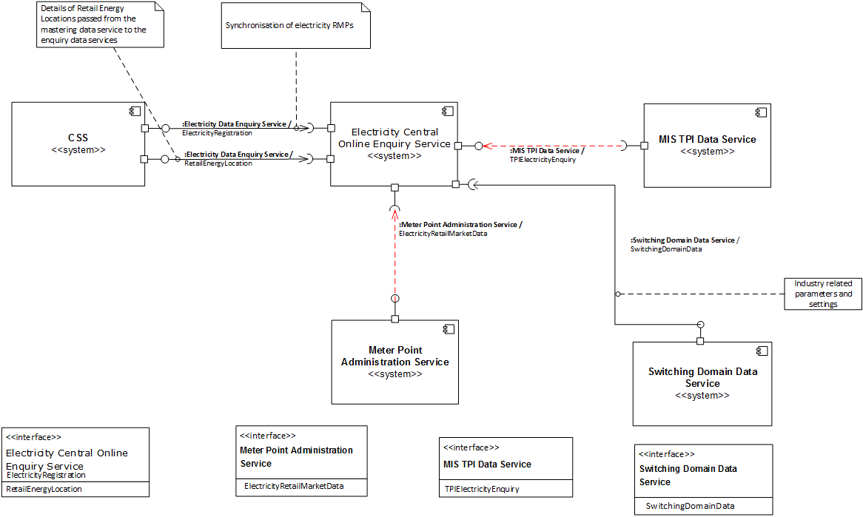

Figure 7 – New/Changed Interfaces with ECOES

## Suppliers and Shippers

### Supplier (Gaining and Losing) Data Service

* 1. Supplier data services will undergo a series of changes related to supporting the switching process for both the Gaining Supplier and the Losing Supplier, including the following:
* Managing Switches and Initial Registrations through the new CSS. Gaining Suppliers have the option to Withdraw switch requests, while Losing suppliers can Object[9] to, or Annul, requests following an “invitation to intervene”. Notifications are also issued at Validation, Confirmation and Securing to both Losing and Gaining Suppliers.
* Managing Switches to tighter timescales than at present, including faster objections processing and faster handover of DCC-enrolled meters.
* Settlement Parameters and Supplier-Appointed Agents may be updated in MPAS or UK Link once these services have been informed of the impending change, which happens when a switch has become Validated or an initial registration has become Confirmed (because this passes immediately to Confirmed when submitted and successfully validated).
* Management of Switch Requests passes from Shipper to Supplier. The Supplier declares the Shipper at Registration and any changes thereafter.
* Setting the domestic premises indicator at Initial Registration and in a Switch Request. Notifying of a change to the domestic premises indicator, should this occur without being associated with a registration change.
* Deactivation of Registrations – this will be initiated by a Registration Management Request submitted over the RegMgmtRequestSubmission interface and will take place in CSS.
* Identification and maintenance of Related RMPs (previously Related MPANs) is through a new RMP Association structure in MPAS including explicit nomination of a ‘Parent’ RMP; suppliers will have to be able to support this and will only need to switch the “parent”.
* For Electricity Suppliers the identification and maintenance of Meter Asset Details and MAP details will be in MPAS, while for Gas Suppliers identifying and maintaining MAP details will be in UK Link. Note Energy Suppliers may choose to outsource maintenance of MAP details to MEMs, but responsibility remains with the Energy Supplier.
* A Losing Supplier in the Switch event must accept returning customers on ‘equivalent terms’ following ‘Cooling Off’ after a completed Switch event if requested to do so by the consumer.
* Initial Registrations can be submitted by either a gaining Energy supplier or an Enforcing Energy Supplier.
  1. New interfaces between Supplier data services and CSS are required to submit Switch Requests. CSS will have the capability to process both inbound and outbound requests as defined in the Interfaces section of this document.
  2. The InvitationToIntervene service interface will provide Losing Suppliers with the option of raising an Objection or Annulment in response to a specified Switch Request. Correspondingly, Suppliers will implement the new SwitchIntervention interface to submit their request to Object or Annul a Switch Request (in response to InvitationToIntervene), to CSS. Suppliers have the option of responding at any point within the defined objections window (which closes as a response is made).
  3. The RegMgmtRequestSubmission interface will provide Gaining Suppliers with the option to Withdraw a Switch Request. This will be permissible once CSS has set a Switch Request to Validated and the Gaining Supplier is notified of the Switch Request Validated status via the RegMgmtRequestNotification interface. Gaining Suppliers have the option of raising this request at any point prior to a Switch Request being set to Secured.
  4. New industry business processes for Gaining and Losing suppliers, and interaction sequence diagrams describing their involvement in these processes, are defined in the Switching Design Repository (ABACUS).
  5. Note: Information about the meter reading processes associated with a switch under CSS is given in D-4.1.6 E2E Operational Choreography[4].

#### Impact Summary

* 1. The following table provides a summary of the new CSS (including Switching Domain Data Service) interfaces that are specified for the Supplier Data Service in ABACUS:

|  |  |  |  |
| --- | --- | --- | --- |
| Interface Name | Directionality | Sending Data Service | Receiving Data Service |
| RegMgmtRequestNotification | Inbound | CSS | Supplier |
| SwitchIntervention | Outbound | Supplier | CSS |
| InvitationToIntervene | Inbound | CSS | Supplier |
| RegMgmtRequestSubmission | Outbound | Supplier | CSS |
| SwitchingDomainData[10] | Inbound | Switching Domain Data Service | Supplier |

* 1. These interfaces are shown in the next diagram:

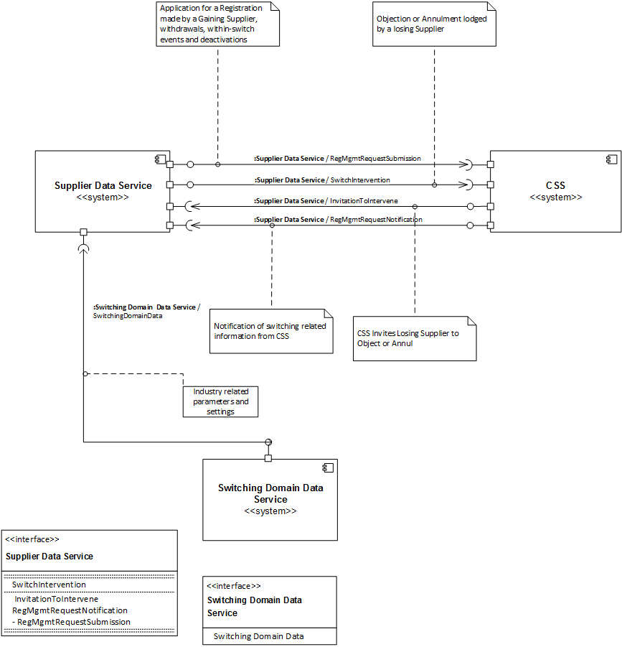

Figure 8 – New/Changed Interface between Supplier and CSS

### Shipper Data Service

* 1. Under the As-Is Switching Arrangements, responsibility for the Gas switching process is led by Shippers. However, harmonisation of Switching Arrangements across Gas and Electricity means that this will be a Supplier led process under the arrangements. There will be changes to the process by which Shippers get transportation quotes from Xoserve.
  2. Consequently, in the new Switching Arrangements, Shippers will only receive notifications from CSS relating to the changing status of Switch Requests submitted by Suppliers. Please refer to the Interfaces section for a list of Notification types issued by CSS.
  3. The new industry business processes for Shippers, and interaction sequence diagrams describing their involvement in these processes, are defined in the Switching Design Repository (ABACUS).

#### Impact Summary

* 1. The following table provides a summary of the new CSS (including Switching Domain Data Service) interfaces that are specified for the Shipper Data Service in ABACUS:

|  |  |  |  |
| --- | --- | --- | --- |
| Interface Name | Directionality | Sending Data Service | Receiving Data Service |
| RegMgmtRequestNotification | Inbound | CSS | Shipper |
| SwitchingDomainData[11] | Inbound | Switching Domain Data Service | Shipper |

* 1. These interfaces are shown in the next diagram:

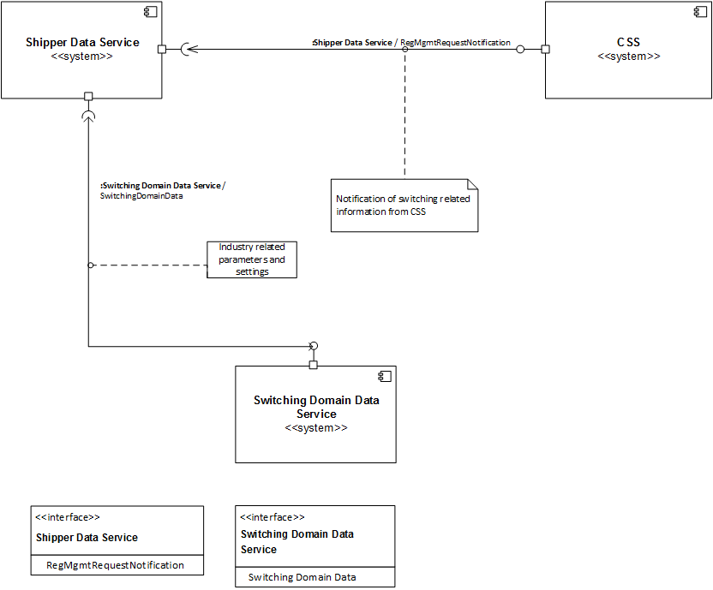

Figure 9 – New/Changed Interface between Shippers and CSS

## Agents

### Data Collectors (DC)

* 1. The Data Collection Service (DC) will require changes related to receiving new notifications related to switched registrations (i.e. switched electricity supplier). This new notification will be transferred through a new interface from CSS to DC services.
  2. The new interface will provide the DC with Notifications from CSS related to changed registrations.
  3. The new industry business processes and interaction sequence diagrams describing the role of DC in these processes, are defined in the Switching Design Repository (ABACUS).

#### Impact Summary

* 1. The following table provides a summary of the new CSS (including Switching Domain Data Service) interfaces that are specified for the Data Collection Service in ABACUS:

|  |  |  |  |
| --- | --- | --- | --- |
| Interface Name | Directionality | Sending Data Service | Receiving Data Service |
| RegMgmtRequestNotification | Inbound | CSS | Data Collection Service |
| SwitchingDomainData[12] | Inbound | Switching Domain Data Service | Data Collection Service |

* 1. These interfaces are shown in the next diagram:

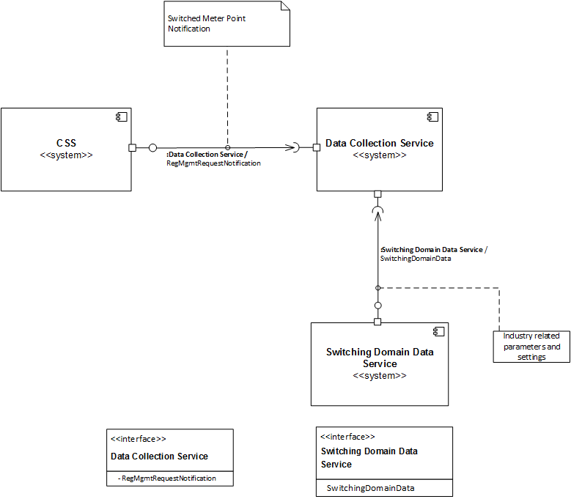

Figure 10 – New/Changed Interface for the Data Collection Service

### Data Aggregators

* 1. Data Aggregators (DAs) may choose to implement changes to their systems related to receiving new switched registration notifications (i.e. switched electricity supplier). This new notification will be transferred through a new interface from CSS to the Data Aggregation Service.
  2. The new interface using the ‘Data Aggregation Service’ will provide DAs with Notifications from CSS related to switched registrations.
  3. The new industry business processes and interaction sequence diagrams describing the role of DAs in these processes, are defined in the Switching Design Repository (ABACUS).

#### Impact Summary

* 1. The following table provides a summary of the new CSS (including Switching Domain Data Service) interfaces that are specified for the Data Aggregation Service in ABACUS:

| Interface Name | Directionality | Sending Data Service | Receiving Data Service |
| --- | --- | --- | --- |
| RegMgmtRequestNotification | Inbound | CSS | Data Aggregation Service |
| SwitchingDomainData[13] | Inbound | Switching Domain Data Service | Data Aggregation Service |

* 1. The new interfaces for the Data Aggregation Service are shown in the next diagram:

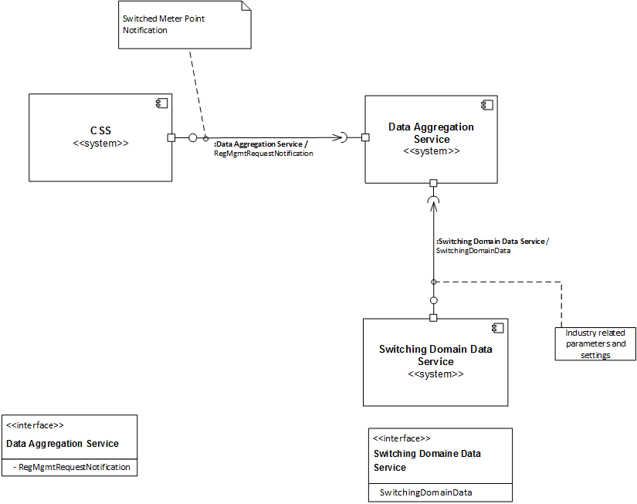

Figure 11 – New/ Interfaces for the Data Aggregation Service

### MEMs

* 1. The MAM and MOP parties that exist within the As-Is arrangements will be consolidated into the new Metering Equipment Manager (MEM) party within the Switching Arrangements.
  2. MEMs will implement changes to the MEM Data Service if they choose to receive new notifications related to switched registrations (i.e. switched electricity supplier). This notification will be transferred through a new interface from CSS to MEM Data Services.
  3. The new interface will provide MEMs with Notifications from CSS related to switched registrations.
  4. Meter asset data (including MAP identity) will be provided to UK Link and MPAS by means of existing interfaces, which may be achieved by an indirect route via the existing Supplier/Shipper interfaces or otherwise.
  5. The new industry business processes and interaction sequence diagrams describing the role of the MEM in these processes, are defined in the Switching Design Repository (ABACUS).

#### Impact Summary

* 1. The following table provides a summary of the new CSS (including Switching Domain Data Service) interfaces that are specified for the MEM Data Service in ABACUS:

|  |  |  |  |
| --- | --- | --- | --- |
| Interface Name | Directionality | Sending Data Service | Receiving Data Service |
| RegMgmtRequestNotification | Inbound | CSS | MEM Data Service |
| SwitchingDomainData[14] | Inbound | Switching Domain Data Service | MEM Data Service |

* 1. These interfaces to are shown in the next diagram:

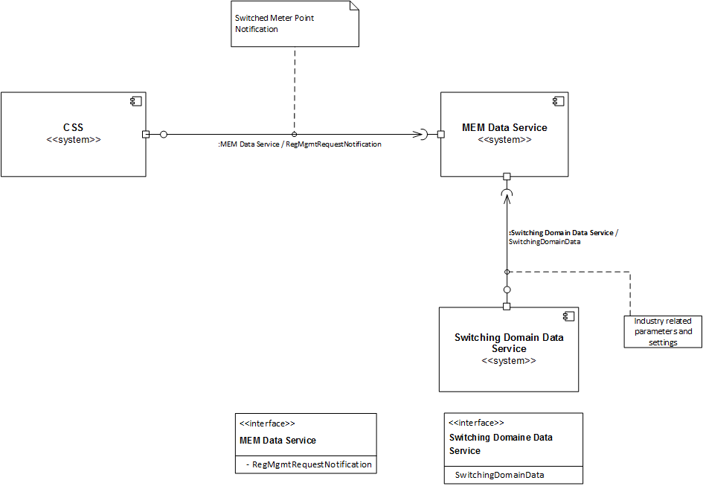

Figure 12 – New/Changed Interface with the MEM Data Services

## Other Participants

### DNOs

* 1. DNOs will implement changes to existing interfaces in order to provide updated meter point status information to MPAS.
  2. The new industry business processes for DNOs, and interaction sequence diagrams describing their involvement in these processes, are defined in the Switching Design Repository (ABACUS).

#### Impact Summary

* 1. The following table provides a summary of the interface not in ABACUS, but is referenced for completeness:

|  |  |  |  |
| --- | --- | --- | --- |
| Interface Name | Directionality | Sending Data Service | Receiving Data Service |
| MeteringPointStatus | Outbound | DNO Data Service | MPAS |
| MeteringPointStatus | Inbound | MPAS | DNO Data Service |

* 1. Note:MeteringPointStatus represents an existing interface between MPAS and DNO Data Service which may require changes under the new arrangements. It is included here for completeness. Any changes necessary as a result of the new Switching Arrangements will need to be agreed directly between the respective Service Owners.
  2. The interfaces are shown in the next diagram:

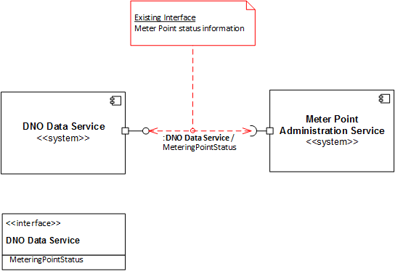

Figure 13 – New/Changed Interfaces for DNOs

### Gas Transporter Data Service

* 1. Gas Transporters (GTs) will require changes to their existing interface(s) to UK Link, to provide updated supply meter point status information.
  2. The new industry business processes for GTs, and interaction sequence diagrams describing their involvement in these processes, are defined in the Switching Design Repository (ABACUS).

#### Impact Summary

* 1. The following table provides a summary of the CSS interfaces that are specified for the GT Data Service:

|  |  |  |  |
| --- | --- | --- | --- |
| Interface Name | Directionality | Sending Data Service | Receiving Data Service |
| SupplyMeterPointStatus | Outbound | Gas Transporter Data Service | UK Link |

* 1. NOTE: SupplyMeterPointStatus is an existing interface between GT Data Service and UK Link. It is included here for completeness. Any changes necessary as a result of the new Switching Arrangements will need to be agreed directly between the respective Service Owners.
  2. The interfaces are shown in the next diagram:

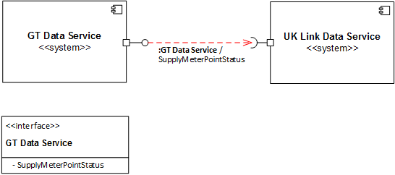

Figure 14 –Changed Interface between GT Data Service and UK Link

### MAPs

* 1. MAPs will implement changes to their data services to receive new Notifications from CSS related to switched registrations.
  2. This data will be transferred through new interfaces between CSS and MAP Data Services.
  3. The MAP ID of the primary asset related to an RMP will be maintained in MPAS and UK Link.
  4. The new industry business processes and interaction sequence diagrams describing the role of the MAP in these processes, are defined in the Switching Design Repository (ABACUS).

#### Impact Summary

* 1. The following table provides a summary of the new CSS (including Switching Domain Data Service) interfaces that are specified for the MAP Data Service in ABACUS:

|  |  |  |  |
| --- | --- | --- | --- |
| Interface Name | Directionality | Sending Data Service | Receiving Data Service |
| RegMgmtRequestNotification | Inbound | CSS | MAP Data Service |
| SwitchingDomainData[15] | Inbound | Switching Domain Data Service | MAP Data Service |

* 1. The interfaces are shown in the next diagram:

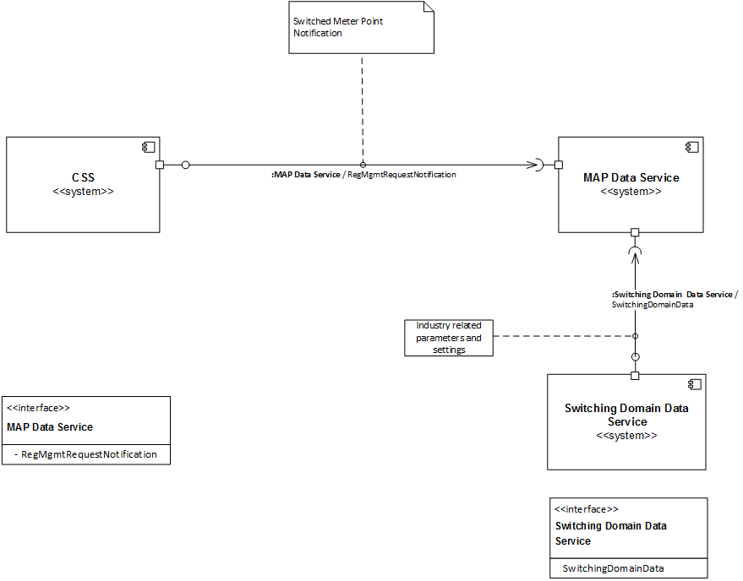

Figure 15 – New/Changed Interfaces with the MAP Data Service

### Settlements

* 1. For Gas, there is no direct impact on UK Link to UK Link (Settlements) as a result of implementing CSS. There is a change to UK Link to provide an update feed of data that represents the switched information (i.e. the switched supplier to meter point relationship) but this change does not present an impact on the current UK Link - Settlements processing and operations. However, the shipper nomination process is changed (e.g. the gas confirmation window is shortened to one working day) and any impact of this should be assessed.
  2. For Electricity, there is no impact on the Data Aggregation Service to Elexon (Settlements) service as a result of implementing CSS. This service will continue to be supported by DA services in its current state and environment (i.e. processing and operations).

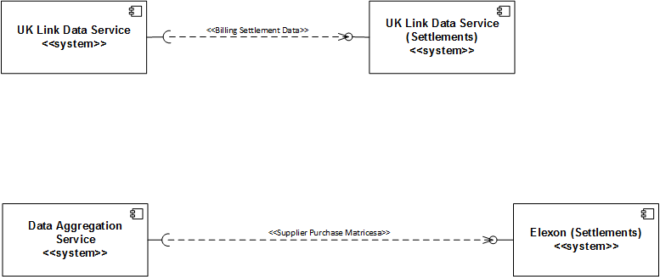

Figure 16 – Interfaces between Settlements

* 1. There are no changes to data formats and interface design, and therefore, no changes are required to be submitted to Code Bodies and Codes (e.g. SEC - Smart Energy Code) documentation regarding data and interfaces.

### Third Party Intermediaries (TPI)

* 1. TPIs (such as Brokers or Price Comparison Websites (PCWs)) will require changes to their interactions with the gas and electricity enquiry services (DES and ECOES), to supplement and enhance the supplier switching functionality of their services. They will need to be able to use the additional address (REL Address) provided by CSS, as well as changed values for the states through which a Registration passes during its lifecycle.
  2. The interfaces using the ‘MIS TPI Data Service’ will provide PCWs with gas and electricity enquiry information from DES and ECOES respectively, to support improved consumer data validation functionality.

#### Impact Summary

* 1. The following table provides a summary of the existing changed interfaces for MIS TPI Data Services which are not specified in ABACUS, but are referenced for completeness:

|  |  |  |  |
| --- | --- | --- | --- |
| Interface Name | Directionality | Sending Data Service | Receiving Data Service |
| TPIGasEnquiry | Outbound | MIS TPI Data Service | DES |
| TPIElectricityEnquiry | Outbound | MIS TPI Data Service | ECOES |

* 1. Note – The above interfaces are included here for completeness. Any changes necessary as a result of the new Switching Arrangements will need to be agreed directly between the respective Service Owners.
  2. The interfaces for MIS TPI Data Services are shown in the next diagram:



Figure 17 – Interfaces to MIS TPI Data Services

### Other Agents

* 1. There are no service impacts to other agents within the E2E Switching Arrangements related to implementing the CSS service. Therefore, there are no further changes to data formats and interface design required to be submitted to Code Bodies and Codes (e.g. SEC - Smart Energy Code) documentation.

### Switching Domain Data Services[16]

* 1. A new service component, switching domain master data management, is delivered by the governance body tasked with regulatory administration of the reformed switching arrangements.
  2. Switching domain master data management follows a unidirectional data-motion pattern. Figure 18 illustrates the pattern, where the direction of movement flows down the page. The flow of data will not be automated and is likely to happen via email or similar.   
      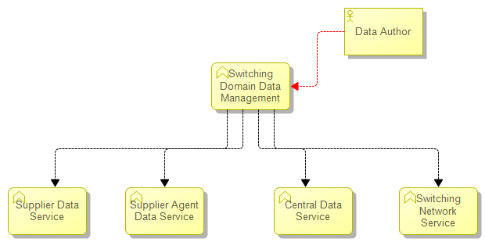

Figure 18: Switching Domain Master Data Management

* 1. Authoring of switching domain data is handled by the governance data body who will coordinate with existing governance bodies. Paper forms, or the electronic equivalent, will gather the inputs that are necessary to author switching domain data. Authoring involves keyboard data entry and equivalent manual assurance of data quality.
  2. Switching domain data is managed using a data co-existence pattern to reduce coupling between the Switching Domain Data Service and destination services. Switching domain data is stored and mastered by the Switching Domain Data Service, and referenced in Central Data Services and the Switching Network. It may also be referenced by other Market Participants who need a definitive record of switching domain data.
  3. The Switching Domain Data Service operates a simple process for dissemination of switching domain data: full-width set of data will be issued to all Market Participants (except for confidential data). Market Participants will choose which switching domain data elements are relevant and store the data locally for subsequent use.
  4. Supplier – shipper alliances are classified as confidential data and are security protected accordingly.
  5. Data that is not confidential is be issued by the Switching Domain Data Service to all Market Participants.
  6. Data that is confidential is issued by the Switching Domain Data Service to the Central Switching Service only.
  7. Data is issued by the Switching Domain Data Service as an incremental change whenever a change to switching domain data occurs.
  8. The governance body considers requests from Market Participants for changes to switching domain data and responds with a corresponding incremental change or a complete refresh as appropriate, should the change be accepted.
  9. Convergent consistency is sufficient for updating Central Data Services with Switching Domain Data. This means that updates are not all applied as part of a single (distributed) transaction which guarantees their consistency. Updates are prioritised by recipient services to enable updates to be applied within a short time of each other (perhaps within an hour or so, as determined by governance) across all Central Data Services.
  10. Business controls are imposed to help avoid inconsistencies arising with recipient data services.
      + Updates cannot be retracted. They are idempotent (if issued again, will have the same effect) to enable them to be re-issued without causing problems;
      + Future-dating is used, rather than waiting until an update needs to be made immediately. This avoids inconsistencies due to delays in updates from the build-up of backlogs of transactions passing from one system to another;
      + No entries will be physically deleted. Where required entries will be through-dated.
  11. No personal or confidential data will be included in Switching Domain Data. Switching Domain Data will adhere to one single data model – the Switching Logical Data Model. No mapping between data will be necessary as all applications will have the same understanding of Object Classes and Data Elements.

1. General Architectural Considerations

## Switching Network

* 1. CSS exchanges messages with other participants using the Switching Network (with the exception of CSS-Smart Metering where communication is via the Smart Metering Gamma network, due to the stringent Smart Metering security requirements).
  2. Volumetrics detailing the total, average and peak number of Switch Requests which must be supported by the Switching Network are laid out in D-4.1.4 E2E Switching Arrangements NFR[3].
  3. Connection to the Switching Network will require Parties to demonstrate compliance with a baseline control set which will be defined by the Security workstream and incorporated into the relevant governance instrument. This will set out the baseline set of Technical, Procedural, Physical and People controls which Parties must meet before the CSS Service Operator will grant access to the Switching Network.
  4. All data services with outbound interfaces (i.e. sending data) to CSS require compliance with the baseline control set.
  5. Data/message flows between the CSS and other services are defined in D-4.1.2 E2E Detailed Design Model[2], with supporting information regarding their sequencing and coordination defined in D-4.1.6 E2E Operational Choreography[4].
  6. D-4.1.10.1 E2E Security Architecture[6] will define the information management controls which will apply to the E2E Switching solution and by implication, the interconnectivity between participants.
  7. Connection-oriented protocols will be supported. Connectionless protocols may also be supported.

## Data Services Architecture

* 1. The thinking and approach behind the E2E Solution Architecture is driven by the D-1.1 Architectural Principles[1]. The Solution Architecture defines a new CSS service that acts as the hub of the new switching service.
  2. There are changes to the switching business process models for both gas and electricity, which necessitate a new end-to-end logical data model including:
* New classes and data elements
* Revisions to existing data classes
* Revised data flows between services, notably around the CSS
* New interface architecture(s)
* A centralised processing component handling elements of the switching process
  1. The Data Model required to enable to Switching Arrangements can be found in the ABACUS Switching Design Repository.
  2. A User Guide to navigating ABACUS is provided in Appendix 2 – Use of Switching Design Repository, which provides information about how to navigate and locate content within the repository.
  3. The ABACUS architecture modelling tool has been used to define the E2E business process flows, data, data services and interfaces required to deliver the Switching Arrangements. This ‘Switching Design Repository’ is the authoritative source of information across these areas.

### Data Model

* 1. The Logical Data Model (LDM) was developed in the Blueprint Phase as an evolution of the Architectural Data Model, although specifically in support of the development option known as Reform Package 2a (RP2a). The model is published in the Switching Design Repository, which connects all design elements of the end-to-end arrangements within a unified model, and is located within ABACUS at:
* Switching > Diagrams > Static Structure > Data Definition > Detailed Design Phase E2E Logical
  1. Specific uses of the LDM include:
* Identifying Data in Motion - new service interfaces with CSS will be expressed with switching LDM concepts.
* Identifying Data at Rest - persistent data stores will be expressed with switching LDM concepts.
* Defining the data mastership of data elements against data service.

### Data Services Landscape

* 1. The E2E Data Services landscape diagram can be found in the Switching Design Model at:
* Switching > Diagrams > Static Structure > Data Services > E2E Data Services Landscape with Message References.
  1. A Data Service is defined as a service, process or service data source used by an Actor to supply and/or receive data within the E2E Switching solution.

#### Data Services Catalogue

* 1. The ABACUS model lists all the data services used by participating actors in the E2E Switching Arrangements. This information is provided as a catalogue within the Switching Design Repository at the following location:
* Services > Data Services Catalogue

#### Data Mastership

* 1. The LDM defines the data items required within the solution and their constituent data elements, and the Data Services Landscape represents the flow of these data items between data services, and is stored in the Switching Design Repository at the following location:
* Services > Data Services Landscape
  1. A Data Mastership matrix has been constructed which augments the LDM and Data Services Landscape by defining the responsibility of each data service in relation to all defined data elements, qualified by three roles:
* M – Master
* S – Secondary
* A – Authorised Provider
  1. The Data Mastership matrix is held in the Switching Design Repository at the following location:
* Data Mastership > Data Mastership Catalogue

## Interfaces

* 1. Where a switching related interface exists between two services and does not include CSS, the respective Service Owners will need to determine how the interface will be implemented to meet the functional and non-functional requirements. Such interfaces have not been referenced in the corresponding sections below.
  2. CSS will have the capability to support messaging transfers as specified for each interface:
* Interface operation – the data is either transmitted as individual messages upon generation or the messages are buffered before communication.
* Interface processing –the receiving data service either processes incoming data communications immediately upon receipt (i.e. interactively), or stores/holds them for later processing.
  1. All interfaces to and from CSS shall support a standard English character set, and additionally (configurable) the character set of any officially-recognised regional language.
  2. The switching arrangements will initially support a next working day and up to 28 calendar days ahead of the chosen switch date. Transitional arrangements may employ a parameterised standstill period (e.g. currently assumed to be five calendar days at go-live).
  3. CSS must be capable of supporting this reduction through interface configuration rather than service upgrades.
  4. The decision on whether a given exchange of information between two services requires messaging or messaging (buffered) processing, is to some degree driven by the Operational Choreography requirement of the E2E business process. However, general architectural considerations, adaptability, and future-proofing of the solution have also been considered. A breakdown of the impact of business processes on each service is given later in this section.
  5. Information describing how the interfaces will be orchestrated, including relevant time dependencies for subsequent processing and/or responses, are provided in D-4.1.6 E2E Operational Choreography[4] , which impacted parties are recommended to review in conjunction with this document.
  6. For the technical architecture of the new interfaces with the CSS, the following principles will apply and should guide impacted parties in their assessments:
* Data/message flows between the CSS and other data services are defined in the Switching Design Repository (ABACUS).
* Interface scheduling, sequencing and coordination is defined in D-4.1.6 E2E Operational Choreography[4], including the flow of individual messages between services and any associated time dependencies for their processing.
* For the purposes of this solution, all services/application components of the solution outside of CSS are ‘black boxes’ – their underlying technical architecture is beyond the scope of this document. However, they are assumed to be capable of exchanging data via the interfaces identified in this document, subject to re-engineering where required (see Assumption A002)
* No assumptions are made regarding the presence, capability or configuration of message oriented middleware or other business-to-business (B2B) integration platforms.
* Services participating in the E2E Switching Arrangements will require connection to a Switching Network’, the design of which will be finalised as part of CSS Detailed Design.
* The Switching Network will implement access control and authentication mechanisms in accordance with requirements laid out in the E2E Security Architecture.
* CSS exchanges messages with other participants using the Switching Network (with the exception of CSS-Smart Metering where communication is via the Smart Metering Gamma network, due to the stringent Smart Metering security requirements).
* Validation and integrity checking will be performed for interfaces in accordance with the appropriate Security requirements, as defined in D-4.1.10.1 E2E Security Architecture[6] and its related products.

### Configurable Functionality

* 1. While this document specifies an initial state of the E2E Architecture, the solution has been defined to be configurable such that it can be configured to make certain adjustments. The permissible functionality configuration adjustments are as follows:
* Removal of the facility for the Supplier to raise an objection (configurable separately for domestic and non-domestic);
* Removal of the facility for the Supplier to raise an objection when the Change of Occupancy Indicator is set (configurable separately for domestic and non-domestic); and
* Removal of the facility for the Supplier to raise an annulment.
  1. All these controls are configurable by the Governance Data Service.
  2. In addition, the length of windows for objections are parameterised and can be set as described in D-4.1.6 E2E Operational Choreography[4].

### Interface Patterns

* 1. Outbound interfaces from CSS have one of the following message interaction patterns:
* **Notifications** – a message between two services that informs the recipient of an event and provides some related information in a structured form. CSS will issue a number of different types of Notification, which Recipients have no requirement to act on and may (or may not) choose to receive:
  + Switch request validated
  + Switch request confirmed (no objection raised)
  + Switch request secured
  + Change of shipper
  + Change of domestic/non-domestic indicator
  + Initial registration confirmed
  + Initial registration secured
  + Switch Objected
  + Switch Withdrawn
  + Switch Annulled
  + Switch Rejected
  + Deactivate registration

The following table gives further detail on the different Notification types:

| Event | Notification |
| --- | --- |
| Switch request validated | Gaining supplier (Elec/Gas): Confirmation that their Switch Request has been validated and is being processed  Gaining shipper (Gas): Notification of pending gain  Losing shipper (Gas): Notification of pending loss |
| Registration Event Request Failure | Supplier: Notification of validation failure (that occurs beyond preliminary validation at Switch Submission) |
| Objection | Losing Supplier: Notification of failure of objection validation |
| Annulment | Losing Supplier: Notification of failure of annulment validation |
| Withdrawal | Gaining Supplier: Notification of failure of withdrawal validation |
| Deactivate Registration | Supplier: Notification of failure of deactivate registration validation |
| Switch request confirmed (no objection raised) | Gaining supplier (Elec/Gas): confirmation that Switch Request has not been objected to  Gaining shipper (Gas): confirmation that Switch Request has not been objected to  Losing supplier (Elec/Gas): confirmation that Switch Request has not been objected to  Losing shipper (Gas): confirmation that Switch Request has not been objected to  All losing agents: Notification of pending loss |
| Switch request secured (gate closure on D-1) | Gaining supplier (Elec/Gas): Notification that Switch Request has become irrevocable  Gaining shipper (Gas): Notification that Switch Request has become irrevocable  Losing supplier (Elec/Gas): Notification that Switch Request has become irrevocable  Losing shipper (Gas): Notification that Switch Request has become irrevocable  All Losing Agents: Notification that Switch Request has become irrevocable  MAP: Notification that Switch Request has become irrevocable |
| Initial registration Confirmed | Gaining supplier (Elec/Gas): notification that the request has been confirmed  Gaining shipper: notification of a request being confirmed |
| Initial registration Secured | Gaining supplier (Elec/Gas): notification that the request has been secured (supplier responsibility)  Gaining shipper (Gas): notification of a request being confirmed |
| Switch Objected | Gaining supplier (Elec/Gas): notification of switch cancellation  Losing supplier (Elec/Gas): notification of switch cancellation  Gaining shipper (Gas): notification of switch cancellation  Losing shipper (Gas): notification of switch cancellation |
| Switch Withdrawn from Validated State  Switch Annulled from Validated State  Switch Rejected from Validated State | Gaining supplier (Elec/Gas): notification of switch cancellation  Losing supplier (Elec/Gas): notification of switch cancellation  Gaining shipper (Gas): notification of switch cancellation  Losing shipper (Gas): notification of switch cancellation |
| Switch Withdrawn from Confirmed State  Switch Annulled from Confirmed State  Switch Rejected from Confirmed State | Gaining supplier (Elec/Gas): notification of switch cancellation  Losing supplier (Elec/Gas): notification of switch cancellation  Gaining shipper (Gas): notification of switch cancellation  Losing shipper (Gas): notification of switch cancellation  Losing DC/DA: notification of switch cancellation  Losing MEM: notification of switch cancellation |
| Deactivate registration | Current supplier (Elec/Gas): notification of registration deactivation  Current shipper (Gas): notification of registration deactivation (to be used for billing)  DC/DA: notification of registration deactivation  MEM: notification of registration deactivation  MAP: notification of registration deactivation |
| Change of Shipper | Current supplier (Gas): notification of registration changes  Current shipper (Gas): notification or registration changes |
| Change of domestic/non-domestic premises indicator | Current supplier (Elec/Gas): notification of registration changes |

* **Enquiry** – a message between two data services that informs the recipient of an event and provides the recipient with an opportunity to respond in a structured form (within a fixed timescale). The response may or may not be mandatory, but confirmation of receipt is required, and the enquiry interfaces are listed in the following table:

|  |  |
| --- | --- |
| Event | Enquiry |
| Switch request validated | Losing supplier (Elec/Gas): Invitation to Intervene |

* **Synchronisation** – a formal mechanism designed to keep information shadowed in one service in line with that mastered in other services. A synchronisation may take place to correspond with an event/activity to ensure that all involved parties share the same information. The synchronisation messages from CSS, MPAS and UK Link are listed in the following table:

| Event | Synchronisation |
| --- | --- |
| Initial registration confirmed | ECOES: Synchronisation of Initial registration request (confirmed)  DES: Synchronisation of Initial registration request (confirmed)  DCC: Synchronisation of registration Initial request (used to update access controls)  UK Link: Synchronisation of Initial registration request (used to update access controls to allow agent/settlement updates)  MPAS: Synchronisation of Initial registration request (used to update access controls to allow agent/settlement updates) |
| Initial registration secured | ECOES: Synchronisation of Initial registration request state update (secured)  DES: Synchronisation of Initial registration request state update (secured)  DCC: Synchronisation that the Initial registration request has become irrevocable (used to update access controls)  UK Link: Synchronisation that the Initial registration request has become irrevocable (used to update access controls to allow agent/settlement updates)  MPAS: Synchronisation that the Initial registration request has become irrevocable (used to update access controls to allow agent/settlement updates) |
| Switch request validated | ECOES: Synchronisation of Switch Request (validated)  DES: Synchronisation of Switch Request (validated)  DCC: Synchronisation of Switch Request (validated)  UK Link: Synchronisation of Switch Request (validated)  MPAS: Synchronisation of Switch Request (validated) |
| Switch request confirmed (no objection raised) | ECOES: Switch Request state update (confirmed)  DES: Switch Request status update (confirmed)  DCC: Synchronisation of pending switch (used to update access controls)  UK Link: Synchronisation of pending switch (used to update access controls to allow agent/settlement updates)  MPAS: Synchronisation of pending switch (used to update access controls to allow agent/settlement updates) |
| Switch request secured (gate closure on D-1) | ECOES: Switch Request status update (secured)  DES: Switch Request state update (secured)  DCC: Synchronisation that Switch Request has become irrevocable (used to update access controls)  UK Link: Synchronisation that Switch Request has become irrevocable (used to update access controls)  MPAS: Synchronisation that Switch Request has become irrevocable (used to update access controls) |
| Agent update | DCC: used to update access controls (for agents) |
| Change of shipper | UK Link: Used to update access controls  DES: used to reflect update |
| Change of domestic/non-domestic indicator | UK Link: used to update settlement values  MPAS: used to update settlement values  DCC: stored in service  ECOES: used to reflect update  DES: used to reflect update |
| Switch Objected | ECOES: Synchronisation of switch cancellation  DES: Synchronisation of switch cancellation  DCC: Synchronisation of Switch cancellation  UK Link: Synchronisation of Switch cancellation  MPAS: Synchronisation of Switch cancellation |
| Switch Withdrawn  Switch Annulled | UK Link: Synchronisation of switch cancellation (note: this does not happen at switch validated)  MPAS: Synchronisation of switch cancellation (note: this does not happen at switch validated)  ECOES: Synchronisation of switch cancellation  DES: Synchronisation of switch cancellation  DCC: Synchronisation of switch cancellation (note: this does not happen at switch validated) |
| Deactivate registration | DCC: Synchronisation of registration deactivation  ECOES: Synchronisation of registration deactivation  DES: Synchronisation of registration deactivation  UK Link: Synchronisation of registration deactivation  MPAS: Synchronisation of registration deactivation |

* 1. Inbound interfaces to CSS follow the **Update** interaction pattern:
* **Update** - A mechanism to issue notifications of proposed changes to switching related master data which must be processed by CSS Acknowledgment of receipt is mandatory, and a formal response message may be required following processing, but is optional. CSS must maintain a record of all Updates received and applied.

|  |  |
| --- | --- |
| Event | Update |
| PremisesAddress | GB Address list updates for CSS, from the Address Service. |
| RegMgmtRequestSubmission | The submission of Initial registration (by a gaining or an enforcing Energy Supplier), Switch requests, Switch Request Withdrawals, Registration Deactivations, Shipper changes, or domestic/non-domestic premises indicator updates from Suppliers to CSS. |

### Interface Operation and Processing

* 1. The immediacy with which a service (application) is required to process data received via an interface has been determined in part by the requirements expressed in D-4.1.6 E2E Operational Choreography[4], but mainly by the desire to provide a platform that uses an up-to-date approach and gives a suitable base on which to build future changes
  2. The interfaces used to exchange data between services must also support these requirements and their operation will fall under one of the following categories:
* **Messaging** –real time interface operation features mechanism to enable the source service to transmit individual (complete) data items/messages/transactions to the service as soon as they are generated.
* **Messaging (buffered)** – as messaging interface operation, but additionally the source or target data services may employ a holding mechanism (buffer) to hold them for later release or processing.
  1. This approach has been adopted in order to future-proof the design. Batch interfaces will not be provided because of the constraints these would impose on the CSS and the Switching Arrangements as a whole. The following table summarises the new interfaces being implemented as part of the Switching Arrangements, the pattern that each will follow and the type of interface necessary. Further details of the interface properties, such as data, are held in ABACUS.

| Interface Name | From | To | Interface Pattern | INTERFACE TYPE | Comment |
| --- | --- | --- | --- | --- | --- |
| CommsHubDataLink | Smart Metering | CSS | Update | Messaging (buffered at source) | Mapping of meter points to comms hub to be used in CSS to improve address quality |
| DADCAppointment | MPAS | CSS | Synchronisation | Messaging (buffered at source) | Synchronisation of DA and/or DC appointments |
| ElectricityRegistration | CSS | ECOES | Synchronisation | Messaging | Delivery of electricity enquiry information. Invoked for the following cases: Registration requests, registration changes (including change of shipper and change of domestic/non-domestic premises indicator), agent updates, Retail Energy Location updates |
| GasRegistration | CSS | DES | Synchronisation | Messaging | Delivery of Gas enquiry information. Invoked for the following cases: Registration requests, registration changes (including change of shipper and change of domestic/non-domestic premises indicator), agent updates, Retail Energy Location updates |
| InvitationToIntervene | CSS | Losing Supplier | Enquiry | Messaging | Invitation to Losing Supplier to respond with an Objection before the window closes or with an Annulment before the Switch Request is secured. |
| MEMAppointment | MPAS | CSS | Synchronisation | Messaging (buffered at source) | Synchronisation of a MEM appointment |
| UK Link | CSS | Synchronisation | Messaging (buffered at source) | Synchronisation of a MEM appointment |
| MeteringPointSync | MPAS | CSS | Synchronisation | Messaging (buffered at source) | Synchronisation of electricity RMPs and associated data, including changes of agents, changes of shipper, and primary asset MAP ownership |
| RegistrationSync | CSS | MPAS  UK Link | Synchronisation | Messaging (buffered at destination) | Synchronisation of Registration changes including updates (e.g. shipper changes) between CSS and MPAS, UK Link. |
| RegistrationSync  Change of Shipper | CSS | UK Link | Synchronisation | Messaging (buffered at destination) | Synchronisation of registration Changes between CSS and UK Link. |
| RegMgmtRequestNotification:  Switch request validated | CSS | Gaining supplier  Gaining shipper  Losing supplier  Losing shipper | Notification | Messaging | Notification of status changes to registration.  Issued from CSS in near real time, no dependency on processing. |
| RegMgmtRequestNotification:  Switch request confirmed (no objection raised) | CSS | Gaining supplier  Gaining shipper  Losing supplier  Losing shipper  Losing DA/DC  Losing MEM | Notification | Messaging | Notification of status changes to registration.  Issued from CSS in near real time, no dependency on processing. |
| RegMgmtRequestNotification:  Switch request secured (gate closure on D-1) | CSS | Gaining supplier  Gaining shipper  Losing supplier  Losing shipper  Losing DA/DC  Losing MEM  MAP | Notification | Messaging | Notification of status changes to registration.  Issued from CSS in near real time, no dependency on processing. |
| RegMgmtRequestNotification:  Initial registration confirmed  Initial registration secured | CSS | Gaining Supplier  Gaining Shipper | Notification | Messaging | Notification of status changes to registration.  Issued from CSS in near real time, no dependency on processing. |
| RegMgmtRequestNotification:  Switch Objected | CSS | Gaining supplier  Gaining shipper  Losing supplier  Losing shipper | Notification | Messaging | Notification of status changes to registration.  Issued from CSS in near real time, no dependency on processing. |
| RegMgmtRequestNotification:  Switch Withdrawn,  Switch Annulled | CSS | Gaining supplier  Losing supplier  Gaining shipper  Losing shipper  Losing DC/DA  Losing MEM | Notification | Messaging | Notification of status changes to registration.  Issued from CSS in near real time, no dependency on processing. |
| RegMgmtRequestNotification:  Deactivate  Registration | CSS | Current supplier  Current shipper  MEM  DC/DA  MAP | Notification | Messaging | Notification of status changes to registration.  Issued from CSS in near real time, no dependency on processing.  Note Deactivate Registration is analogous to the existing Shipper Withdrawal. |
| RegMgmtRequestSubmission | Supplier | CSS | Update | Messaging | Switch requests, Switch Request Withdrawals, Registration Deactivations, Shipper changes, or domestic/non-domestic premises indicator updates |
| RetailEnergyLocation | CSS | ECOES | Synchronisation | Messaging | Updating Retail Energy Location in ECOES |
| CSS | DES | Synchronisation | Messaging | Updating Retail Energy Location in DES |
| CSS | MPAS | Synchronisation | Messaging | Updating Retail Energy Location in MPAS |
| CSS | UK Link | Synchronisation | Messaging | Updating Retail Energy Location in UK Link |
| RMPRegApptSync | CSS | Smart Metering | Synchronisation | Messaging | Smart metering will need to know about the Supplier and MEM changes to give them access to the meter to process commands, take readings, etc. |
| SupplyMeterPointSync | CSS | UK Link | Synchronisation | Messaging (buffered) | Synchronisation of gas RMPs and associated data, including changes to registration, shipper, registration status, or primary asset MAP ownership |
| [SwitchingDomainData](javascript:void((window.app||parent.app).HandlePopUpContent('Content/Components/3808211.html'))) | Switching Domain Data Service | [MAP Data Service](javascript:void((window.app||parent.app).HandlePopUpContent('Content/Components/3733051.html'))) [Supplier Data Service](javascript:void((window.app||parent.app).HandlePopUpContent('Content/Components/3724865.html'))) [UK Link](javascript:void((window.app||parent.app).HandlePopUpContent('Content/Components/3724895.html'))) [ECOES](javascript:void((window.app||parent.app).HandlePopUpContent('Content/Components/3751239.html'))) [DES](javascript:void((window.app||parent.app).HandlePopUpContent('Content/Components/3751241.html'))) [MPAS](javascript:void((window.app||parent.app).HandlePopUpContent('Content/Components/3724896.html'))) [Smart Metering Data Service](javascript:void((window.app||parent.app).HandlePopUpContent('Content/Components/3733053.html'))) [CSS](javascript:void((window.app||parent.app).HandlePopUpContent('Content/Components/3724875.html'))) [Data Collection Service](javascript:void((window.app||parent.app).HandlePopUpContent('Content/Components/3724905.html'))) [Data Aggregation Service](javascript:void((window.app||parent.app).HandlePopUpContent('Content/Components/3724904.html'))) [Shipper Data Service](javascript:void((window.app||parent.app).HandlePopUpContent('Content/Components/3724945.html'))) [MEM Data Service](javascript:void((window.app||parent.app).HandlePopUpContent('Content/Components/3748684.html'))) | n/a | n/a | Information published by industry governance concerning the parameters and settings applicable across all participants in switching processes. This information may be transmitted by manual means, such as email. |
| SwitchIntervention | Supplier | CSS | Update | Messaging | Required for Objection and Annulments |

2. CSS and Address Service Architecture
   1. This section provides high-level information on the CSS and Address Service architecture. Further information is provided in the CSS User Requirement Specification.
   2. It is intended that CSS and the Address Service will be procured at the same time. The two may or may not be provided by the same service provider. It is envisaged that the Address Service will be Commercial Off-The Shelf software and that the detailed functionality it provides will be largely determined by the software package selected, acknowledging that the selected service provider must meet the specified requirements. For this reason, the interface between CSS and the Address Service is specified at a logical level in terms of the data exchanged and cannot at this point be provided in more detail; this will be more fully specified at a later point in the Programme. The interface is not included in Figure 19 - CSS Inbound Interfaces nor Figure 20 - CSS Outbound Interfaces but is described separate in a subsequent section.

### CSS Inbound Interfaces

* 1. In Figure 19 - CSS Inbound Interfaces, below, the external systems are shown as a single component with connectivity to CSS over a network connection. Text on the connectors indicates the data services associated with that interface.



Figure 19 - CSS Inbound Interfaces

| Interface Name | Purpose | Interface User | Pattern |
| --- | --- | --- | --- |
| CommsHubDataLink | Information that relates the electricity and gas meters connected to the same communications hub | Smart Metering Data Service | U |
| DADCAppointment | Synchronisation of Data Aggregator and Data Collector Appointments between the mastering and secondary (referencing) data services | MPAS | S |
| MEMAppointment | Specifies the MEM agents appointed by the energy supplier for a specified MPAN or MPRNs. Synchronisation of Supplier arranged Agent appointments between the mastering and secondary (referencing) data services | MPAS  UK Link | S |
| MeteringPointSync | Synchronisation of electricity Metering Points and associated attributes including MAP ID | MPAS | S |
| RegMgmtRequestSubmission | Registration Requests submitted by a gaining supplier, withdrawals, Registration events and deactivation requests | Supplier | U |
| SwitchIntervention | Objection or Annulment lodged by a losing supplier | Supplier | U |
| SwitchingDomainData | Information published by industry governance concerning the parameters and settings applicable across all participants in switching processes. This will be transferred manually e.g. by email and there is an Operations facility in CSS to load the data from a simple file. | Switching Domain Data Service | n/a |

### CSS Outbound Interfaces



Figure 20 - CSS Outbound Interfaces

| Interface Name | Purpose | Interface User | Pattern |
| --- | --- | --- | --- |
| ElectricityRegistration | Synchronisation of electricity RMPs between the mastering and secondary (referencing) data services | ECOES | S |
| GasRegistration | Synchronisation of gas RMPs between the mastering and secondary (referencing) data services | DES | S |
| InvitationToIntervene | Registration details delivered to the losing supplier to provide an opportunity to object or annul within the timing constraints of the Switching windows. | Losing supplier | E |
| RegistrationSync | Synchronisation of Registrations between the mastering and secondary (referencing) data services | MPAS  UK Link | S |
| RegMgmtRequest Notification | Registration details passed to interested parties subsequent relating to receipt of a valid registration request, withdrawals, within-switch events and deactivations | Gaining supplier  Gaining shipper  Losing supplier  Losing shipper  Losing DC / DA  MAP  Losing MEM | N |
| RetailEnergyLocation | Details of Retail Energy Locations passed from the mastering data service to the enquiry data services | ECOES  DES | S |
| RMPRegApptSync | Synchronisation of RMPs, Registration and Appointment details | Smart Metering Data Service | S |

### CSS Functional Architecture



Figure 21 - CSS Functional Architecture

* 1. The key functionality for the Interface Manager is as follows:

|  |  |
| --- | --- |
| Message Gateway | Receives incoming messages from external parties including losing suppliers, gaining suppliers, MPAS, UK Link, DES, and ECOES etc. The Message gateway authenticates the messages, the source of the messages as well as their validity, conformity and complicity; if any of the message is not conformant, it is rejected. Message gateway is also responsible to establish the TLS end points with the external parties over the Switching Network, and can also provide load balancing to meet scalability requirements. |
| Request Manager | Checks and authorises incoming messages to execute workflows or trigger switching. The Request Manager filters or transforms the messages so they can be processed as required by the Process Orchestration Management process. The Request Manager checks whether any disallowed new Service requests are coming while an existing transaction is already in progress. Request Manger monitors transactions for successful or failed acknowledgements. After doing these additional checks, Request Manager then routes this message to CSS Process Manager. |
| Process Manager | Responsible for the execution of the switching business processes and their orchestration. After initiation by the Request Manager, requests invoke a new switching process in CSS with the required input data and its related transformation. |
| Response Manager | Responsible for any messages that need to be sent outside CSS. The Response Manager prepares the necessary transformations of the messages plus any wrappers needed to define which message needs to go to which external party. Response Manager can define messages depending on the business processes and requirements, then transforms the messages based on Security and Interfaces requirements. |

* 1. Other CSS functionality includes:

|  |  |
| --- | --- |
| External Interfaces and Security | CSS provides external interfaces to external parties, which will be secured by the appropriate security controls set out in the CSS security requirements. These interfaces act as a bridging point between CSS and external services. |
| Business Process Execution Layer and Business Rules Engine | Is used for modelling and orchestrating the behaviour of business processes using web-service interactions (e.g. the inter-service interfaces within the E2E solution). Business Rules are used to define what actions can be taken at any point in a process flow, and the constraints which apply to them. |
| Application Server and Database (DBMS) | The database(s) hold information including suppliers, premises, and meters, with processing facilitated by the application servers. |

### CSS and Address Service

* 1. The following diagram illustrates at a high level the distinction between CSS and the Address Service functions and the relationship between the Address Service and gazetteer services, which will act as the primary source of GB geographical data. The gazetteer services used will depend on the Address Service solution selected.



Figure 22 - Relationship Between CSS and Address Service

* 1. CSS masters and maintains the Retail Energy Location (REL) Address. The REL address will stem from the Meter Point Location (MPL) address provided by the network operator or an address provided by the supplier (manually entered into CSS). In either case the address supplied will be matched – by means of the Address Service - to a list of standardised GB addresses. This should maximise the probability of recording a legitimate REL address that the consumer will recognise.
  2. In some cases, the meter points are sited at a different location from the premises where energy is consumed. The REL may be derived from the MPL or may be subject to an over-ride advised by a supplier (possibly based on customer feedback). Customers are expected to specify the REL address when identifying the energy supply they wish to switch. The REL addresses for gas and electricity meter points supplying the same premises should be identical.

# Appendix 1 – Glossary

| Acronym / Term | Definition |
| --- | --- |
| API | Application Program Interface |
| CSS | Central Switching Service |
| DBMS | Database Management Service |
| E2E | End-to-End |
| LDM | Logical Data Model |
| LEN | Licence Exempt Networks |
| N/A | Not Applicable |
| NFR | Non-Functional Requirements |
| RDP | Registration Data Provider |
| RMP | Registrable Measurement Point |
| RP2a | A version of Reform Package 0 to 3, outlining options for the Switching Programme |
| TCoS | Transitional Change of Supplier |
| TPIs | Third Party Intermediaries |
| XML | eXtensible Markup Language |

# 

# Appendix 2 – Use of Switching Design Repository

The attached slides provide an explanation of the content which can be found within the Switching Design Repository (ABACUS), where to find it and how to navigate it.



# Appendix 3 – Structure of the DES Service

UK Link is the service through which GTs, iGTs and Shippers interact to maintain (amongst other things) the supply point register. An extract from UK Link is taken to the SAP Business Warehouse (SAP BW), from where all data provision services are provided. This ensures that any data provision services cannot impact the performance of the core UK Link service.

This is shown in the figure below which depicts the flow of information to the Xoserve SAP BW service which is utilised as the source for key data provisioning activities.

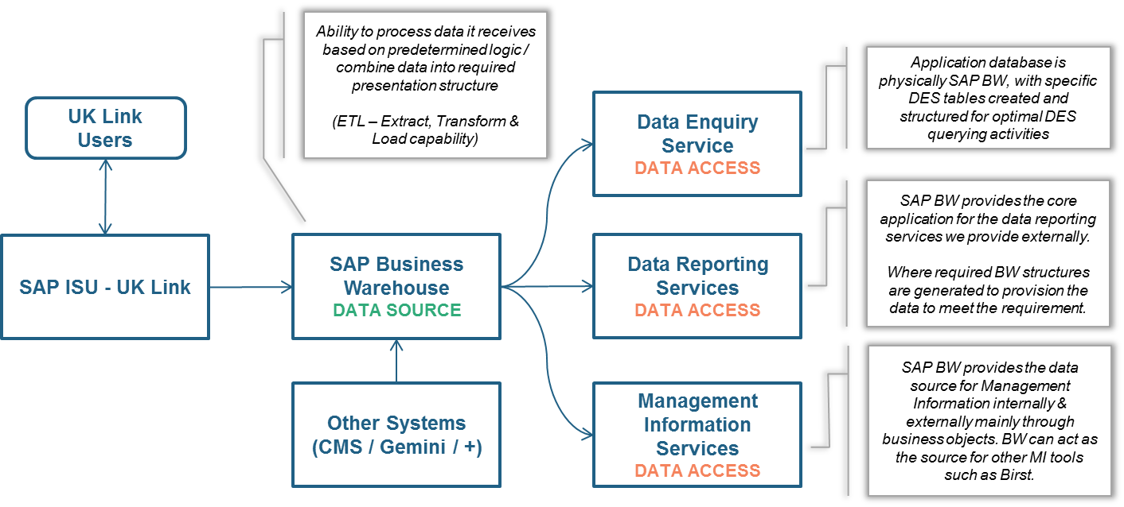

Figure 23 – Information Flow for UK Link

1. This referred to in ABACUS as DCC Data Service
2. This referred to in ABACUS as Governance Data Service
3. This interface is not envisaged to be system-to-system, but to use some other means of distributing the Switching Domain Data, possibly email. This will ensure that all participants possess a common set of data.
4. This interface is not envisaged to be system-to-system, but to use some other means of distributing the Switching Domain Data, possibly email. This will ensure that all participants possess a common set of data.
5. The existing interfaces are specified in Registration Data Interface Specification at ttps://www.smartdcc.co.uk/implementation/design-and-assurance/interface-specifications/registration-data-interface-specification/
6. This interface is not envisaged to be system-to-system, but to use some other means of distributing the Switching Domain Data, possibly email. This will ensure that all participants possess a common set of data.
7. This interface is not envisaged to be system-to-system, but to use some other means of distributing the Switching Domain Data, possibly email. This will ensure that all participants possess a common set of data.
8. This interface is not envisaged to be system-to-system, but to use some other means of distributing the Switching Domain Data, possibly email. This will ensure that all participants possess a common set of data.
9. Objection reasons will be set out in regulation, but will no longer include Related RMPs as a valid reason
10. This interface is not envisaged to be system-to-system, but to use some other means of distributing the Switching Domain Data, possibly email. This will ensure that all participants possess a common set of data.
11. This interface is not envisaged to be system-to-system, but to use some other means of distributing the Switching Domain Data, possibly email. This will ensure that all participants possess a common set of data.
12. This interface is not envisaged to be system-to-system, but to use some other means of distributing the Switching Domain Data, possibly email. This will ensure that all participants possess a common set of data.
13. This interface is not envisaged to be system-to-system, but to use some other means of distributing the Switching Domain Data, possibly email. This will ensure that all participants possess a common set of data.
14. This interface is not envisaged to be system-to-system, but to use some other means of distributing the Switching Domain Data, possibly email. This will ensure that all participants possess a common set of data.
15. This interface is not envisaged to be system-to-system, but to use some other means of distributing the Switching Domain Data, possibly email. This will ensure that all participants possess a common set of data.
16. This section contains terms relating to the specialised subjects of Data Management and Master Data Management