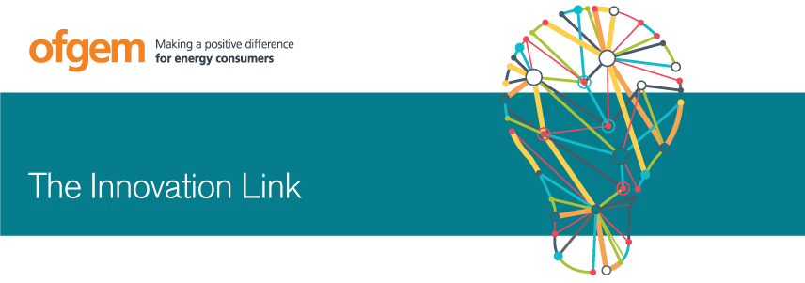
Roundtable on regulatory constraints and enablers of blockchain in the GB energy sector
The Innovation Link held a roundtable on 13th September 2017 with leading industry experts, academics and innovators looking at the potential of blockchain in the energy sector. Our aim was to start a conversation about blockchain in energy and to understand the potential for blockchain technology to drive the changes to transactions in the energy sector. The session opened by Professor David Shipworth, UCL.
What is blockchain?
Blockchain is a distributed ledger: it provides a transparent ledger of transactions between decentralised parties, which automatically reference one another, forming an unbroken chain. Blockchain is considered to be secure and able to authenticate transactions. As the ledger is distributed, it does not require a centralised party to clear and settle transactions. Blockchain technology is more developed in the financial sector with it being the technology that enables, cryptocurrencies, such as bitcoin.
Applications of blockchain in energy
We grouped the potential use cases of blockchain in energy, and invited presentations from people across the industry with experience in each area:
- Developing a single platform that will operate across a range of low carbon technologies (Daniel Mee, Energy System Catapult)
- Automated regulatory compliance and dispute resolution (Tomasz Mloduckowski, Resilience Partners)
- A technology to enable fast and more accurate switching between suppliers (Jo Jo Hubbard, Electron)
- Verifying trades of energy whilst preserving anonymity (Tilo Zimmerman, Ponton Enerchain)
- A micro payment app for people who don’t have access to a bank account (Neil Pennington, DISC Holdings)
- Disaggregating energy use and authenticating and evidencing Demand Side Response (DSR) (Peter Davies, Green Runnings)
- Mass market, real time DSR enabling people to “set it and forget it” (Scott Kesler, LO3)
- Peer to Peer electricity trading for residential consumers (Maria Bucolli, Edf)
Main points and discussions
Consumer adoption and trust: How can participants be sure that blockchain is trustworthy? Should participation be opt in or opt out? This has implications for “informed consumers”.
Data security and privacy: How can we ensure data security whilst sharing? For example, if the blockchain contains information on which customers have solar PV, this could be used for the good of customers (e.g. to help people identify cheaper tariffs, or better batteries) but could also result in customer detriment (e.g. unsolicited marketing). So data privacy and allowing consumers to control who accesses their data will be important.
Underwriting: Transaction costs provide value in the form of underwriting payments, removing transaction costs might leave a gap. If something goes wrong, should the Government or Ofgem underwrite transactions? (with particular reference to imbalance electricity supply/demand risks).
Dispute resolution: If there are many players in a chain, how can you resolve disputes between multiple parties?
Interaction between blockchain and the existing wholesale market: Do blockchain trades happen in parallel with the existing wholesale market?
Transition to Blockchain: How quickly can big companies move to blockchain, and how necessary is this? It took some big companies a long time to move to using computers.
Governance: Who operates any of these blockchain markets? Is it a private or public organisation? Will there be a national regulatory authority, and what happens when blockchain transactions cut through geographical boundaries?
Sharing: Not everything needs to go on a blockchain, we only need to share information that is of value. How do we differentiate?
Future of regulation: What does blockchain mean for the future of regulation? Should it move away from rules based regulation to outcome based regulation?
Equity: Some consumers may live in areas with local peer to peer trading networks who can therefore access electricity much more cheaply than those outside of these areas. How can ensure blockchain doesn’t further marginalise people? What about people who are not prosumers?
Next steps
A more detailed report on this event and its regulatory implications will be available in the new year. We will also hold further exploratory sessions on blockchain and other relevant topics in 2018.

