21st September 2017

Notice of reasons to issue a direction pursuant to Standard condition 32A – directions for provision of information pursuant to participation in randomised control trial

This letter sets out the reasons for the decision of the Gas and Electricity Markets Authority (“the Authority”) to issue directions pursuant to standard licence condition (“SLC”) 32A (Power to direct suppliers to test consumer engagement measures) of the electricity and gas supply licences of [supplier name redacted].

Background to, and rationale for, the directions:

The directions were issued pursuant to the previous directions issued to [supplier name redacted] on 8 June 2017 regarding the Cheaper Markets Offer Letter (CMOL) trial (the CMOL Directions). The directions require [supplier name redacted] to provide specified information to a third party in order to facilitate the assessment of feedback gathered from the randomised control trial, which [supplier name redacted] participated in by virtue of the CMOL Directions.

[supplier name redacted] was selected in accordance with GEMA’s published criteria to participate in the randomised control trial as described in the CMOL Directions and accompanying letter.

The Authority issued the direction requiring [supplier name redacted] to provide specified information in accordance with SLC 32A to a third party agency with the intention of conducting qualitative telephone interviews with trial subjects from the CMOL trial. The relevant data is to be provided in the format specified in the schedule to the direction by such date as notified to [supplier name redacted] in order to facilitate compliance with the CMOL Direction.

Yours faithfully,

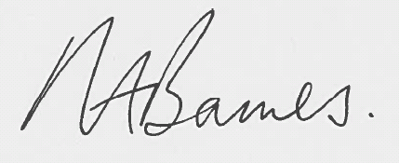

Neil Barnes
Associate Partner, Consumers and Competition
Signed on behalf of the Authority and authorised for that purpose.

As required by s. 49A Electricity Act 1989 and s. 38A Gas Act 1986
https://authors.ofgem.gov.uk/system/files/docs/2017/01/decision_selection_criteria_0.pdf

