Annex 1 – Open letter consultation on the Incentive of Connections Engagement
  - We would like to hear the views of interested parties in relation to any of the issues set out in our open consultation letter.

  - We would especially welcome responses to the specific questions in our consultation, which are replicated below.

  - If you have any questions on this document please contact:

James Veaney
Head of Connections and Constraint Management
Ofgem, 9 Millbank, London, SW1P 3GE
020 7901 1861
Connections@Ofgem.gov.uk

  - Responses should be sent, preferably by e-mail by 27 July 2017 to the address above.

  - Unless marked confidential, all responses will be published by placing them in Ofgem’s library and on its website www.ofgem.gov.uk. Respondents may request that their response is kept confidential. Ofgem shall respect this request, subject to any obligations to disclose information, for example, under the Freedom of Information Act 2000 or the Environmental Information Regulations 2004.

  - Respondents who wish to have their responses kept confidential should clearly mark the document/s to that effect and include the reasons for confidentiality. Respondents are asked to put any confidential material in the appendices to their responses.

  - Next steps: We will consider the responses to this consultation and these will be used alongside other evidence for our assessment of the ICE plans.

  - Each of the questions asked by this consultation is set out in the template below.

  - Please ensure that you indicate the DNO group or specific licence area to which your experiences relate.

  - Please ensure that you indicate clearly the type of connection you generally require.

  - When considering your responses to these questions, please consider your experiences, the actions that the DNO has undertaken or committed to undertake, and the actions that you consider it could reasonably undertake.

Response template – Incentive on Connections Engagement June 2017
Question | Response
About you and your work
- What is the name of your company?
- Which DNO’s ICE submission is your response related to (see Annex 2 for DNO map)?
Please indicate clearly in your response to the questions below whether your comments refer to the DNO’s plans as a whole, or to one of the DNO’s licence areas.
If you wish to provide a response to the ICE submission of more than one DNO, please use a separate template for each DNO.
- What type of connection do you generally require? And for each type of connection, how many connection applications, including total MVA (Mega Volt Ampere) of connections have you made in the past year?  Please note that we will assess storage within the relevant metered generation market segment. |  | Type of connection Total number of connections Total MVA of connections  Metered Demand Connections Low Voltage (LV) Work  High Voltage (HV) Work  HV and Extra High Voltage (EHV) Work  EHV work and above  Metered Distributed Generation (DG) LV work  HV and EHV work  Unmetered Connections Local Authority (LA) work  Private finance initiatives (PFI) Work  Other work
Consultation questions
Section 1: Looking Back report 2016-17
We want your views on how well the DNOs have performed over the last year
- Are you satisfied that the DNO had a comprehensive and robust strategy for engaging with connections stakeholders? Do you consider that the DNO implemented its strategy? If not, are you satisfied that the DNO has provided a reasonable and well-justified explanation?
- Are you satisfied that the DNO had a comprehensive work plan of activities (with associated delivery dates) to meet the requirements of its connections stakeholders? Do you consider that the DNO delivered its work plan? If not, are you satisfied that the DNO has provided a reasonable and well-justified explanation?
- Do you consider that the DNO’s work plan provided relevant outputs (eg key performance indicators, targets etc.)? Are you satisfied that the DNO has delivered these outputs? If not, do you view the reasons provided to be reasonable and well justified?
- Do you agree that the DNO’s strategy, activities and outputs have taken into account ongoing feedback from a broad and inclusive range of connections stakeholders? If not, has the DNO provided reasonable justification?
The following two questions refer to the specific areas we discuss in our letter – meeting the needs of all types of connections customers, and connecting when the networks are constrained.
- Do you consider that the DNO’s activities and outputs over the past year were adequate in meeting the needs of all types of connection customers, including the particular needs of newer types of connection customers?
- Do you consider that the DNO’s activities and outputs over the past year were adequate in meeting the needs of customers looking to connect when the networks are constrained?
Section 2: Looking Forward plans 2017-18
We want your views on what the DNOs aim to achieve in the coming year
- Are you satisfied that the DNO has a comprehensive and robust strategy for engaging with connection stakeholders and facilitating joint discussions where appropriate?
- Do you agree that the DNO has a comprehensive work plan of activities (with associated delivery dates) that will meet the requirements of its connection stakeholders? If not, has the DNO provided reasonable and well-justified reasons? What other activities should the DNOs do?
- Do you consider that the DNO has set relevant outputs that it will deliver during the regulatory year (eg key performance indicators, targets, etc.)?
- Would you agree that the DNO’s proposed strategy, activities and outputs have been informed and endorsed by a broad and inclusive range of connection stakeholders? If they have not been endorsed, has the DNO provided robust evidence that it has pursued this?
The following two questions refer to the specific areas we discuss in our letter – meeting the needs of all types of connections customers, and connecting when the networks are constrained.
- Do you consider that the DNO’s planned activities and outputs will be sufficient to meet the needs of all types of connection customers, including the particular needs of newer types of connection customers? What other activities should the DNO undertake in this area?
- Do you consider that the DNO’s planned activities and outputs will be sufficient to meet the needs of customers looking to connect when the networks are constrained? What other activities should the DNO undertake in this area?

Annex 2 - Map showing DNO licensee areas

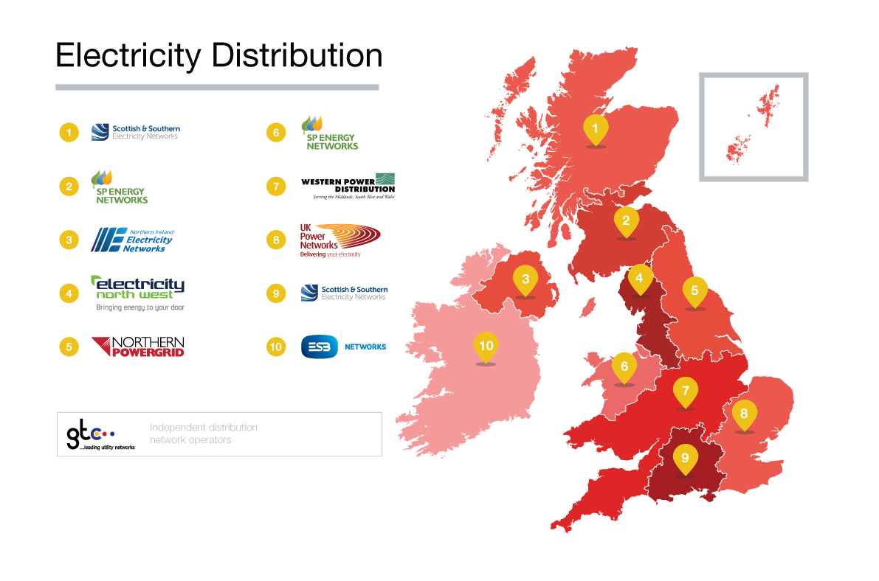

Image from Electricity Networks Association (ENA) – note the ICE only applies to distribution networks operating in GB

