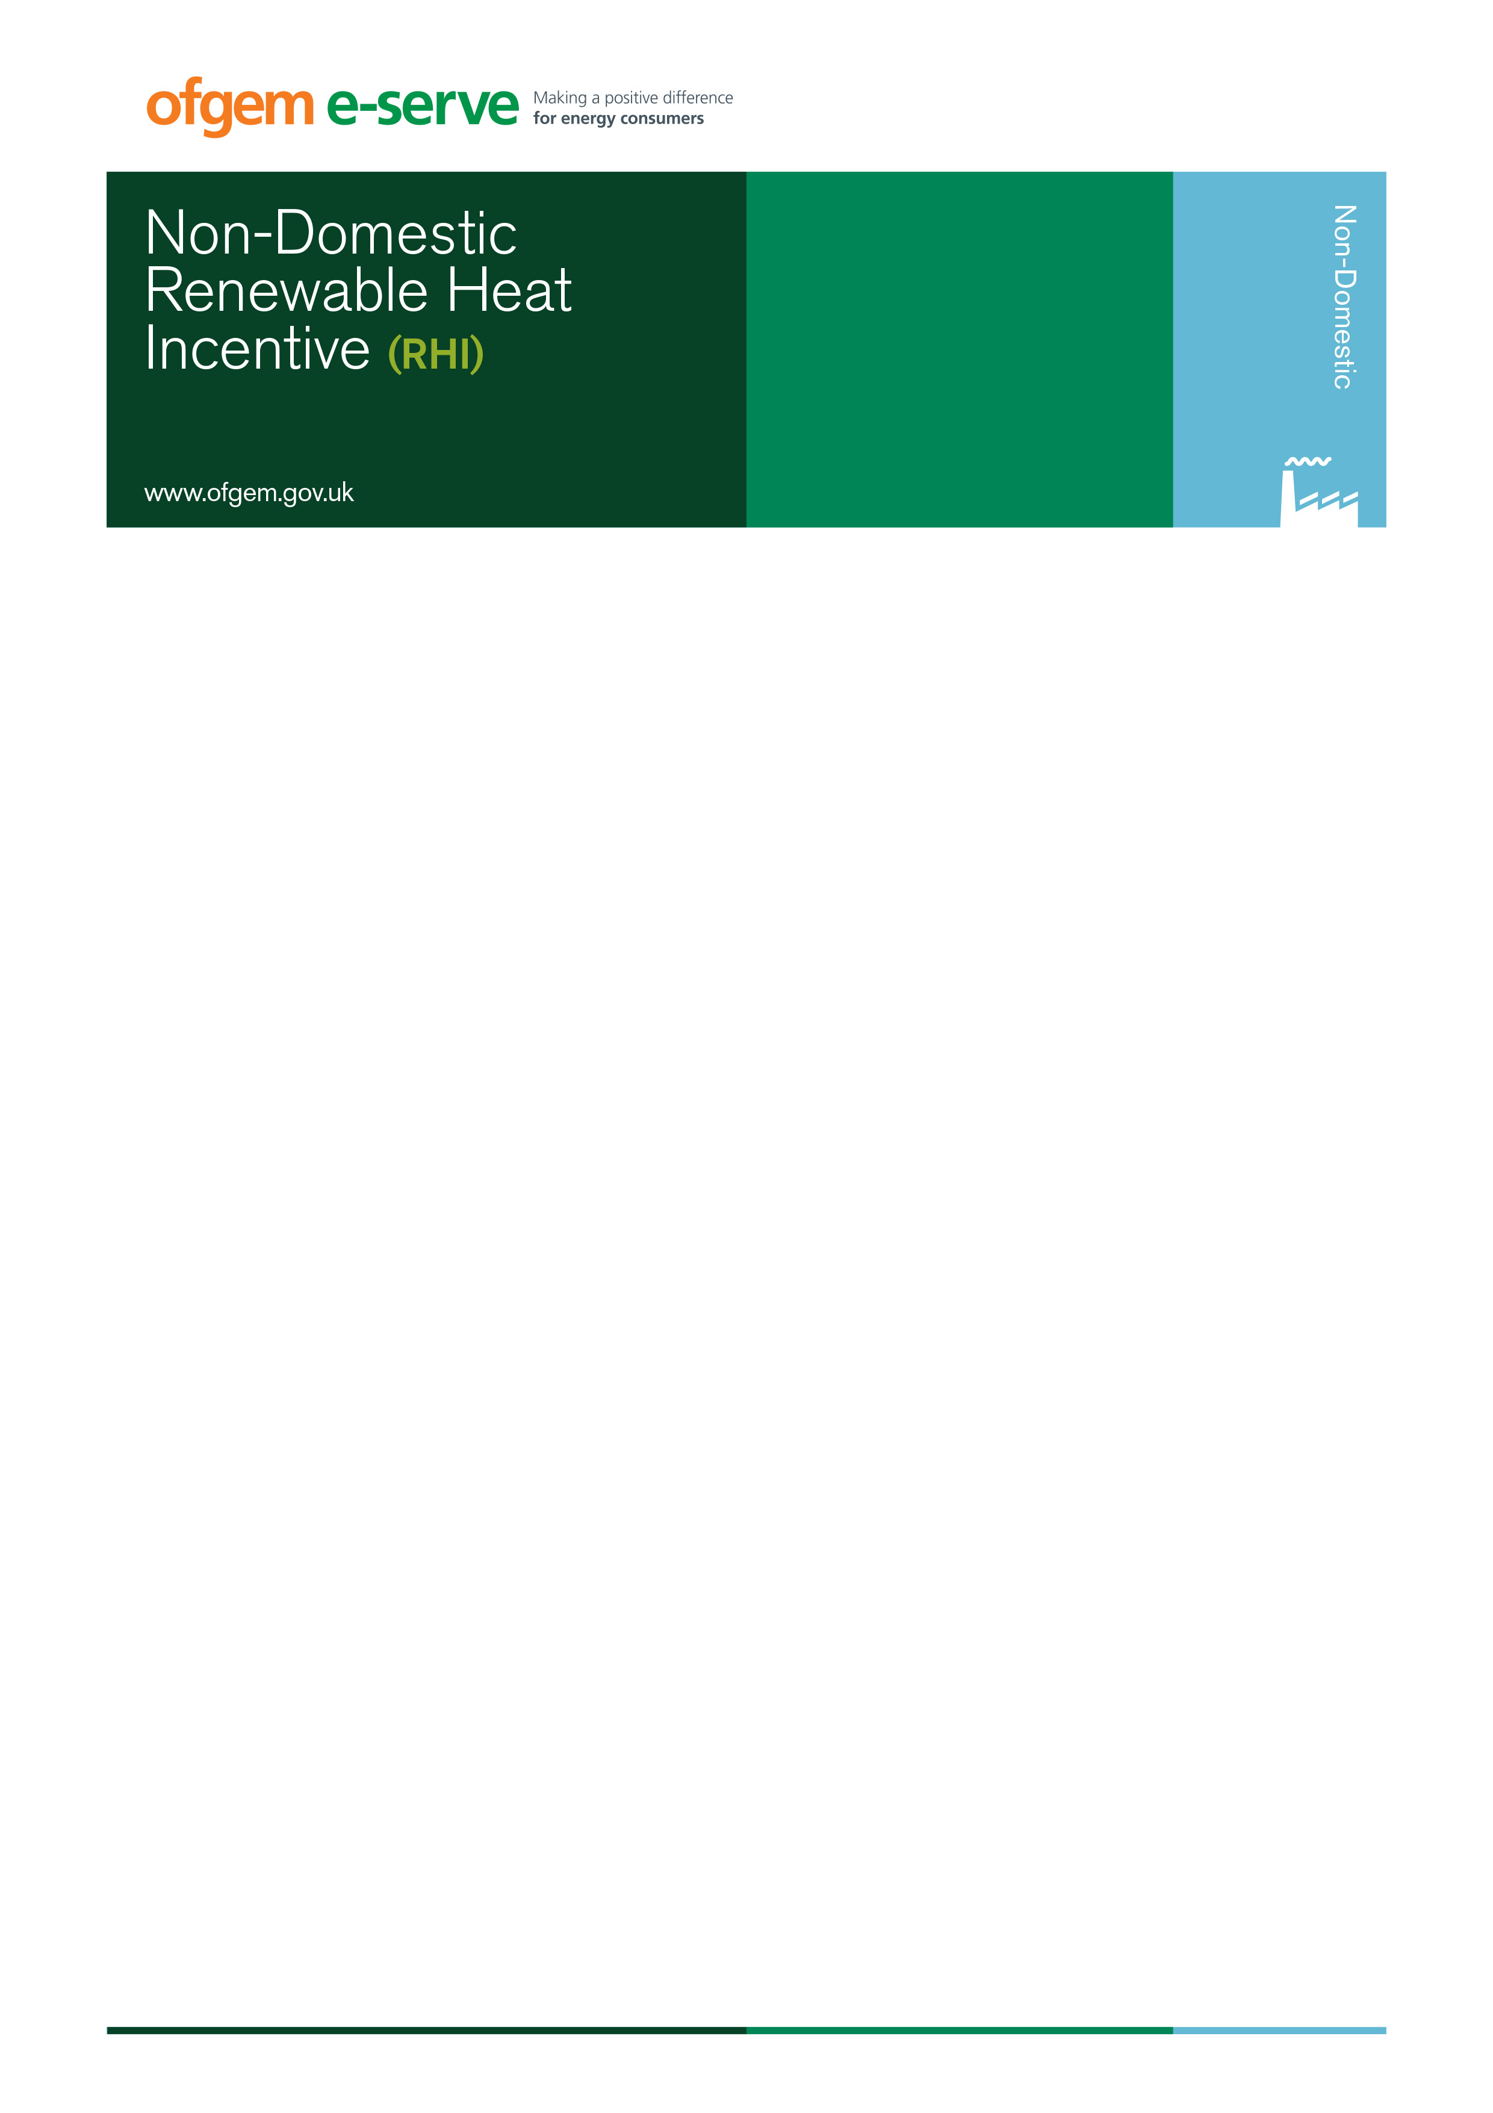

RENEWABLE HEAT INCENTIVE (RHI)

STATE AID DECLARATION – DRAFT DECLARATION TEMPLATE

To proceed with your RHI application we request you complete a declaration, by your completing and signing the document below, that your undertaking has not received ‘de minimis’ aid exceeding €200,000 in the previous three years and will not, as a result of any Renewable Heat Incentive funding, receive ‘de minimis’ aid exceeding €200,000 in any 3 financial year rolling period

To help assess if your undertaking will exceed the €200,000 (c.£170,000) limit, please complete the following calculation to determine the maximum amount of aid that your Renewable Heat Incentive payments may represent:

RHI Installation Capacity (kW) | C | kW
Anticipated RHI tariff at date of accreditation (p/kWh) | T | p/kWh
Number of installation operating hours in one year (please use the same figure used in your Carbon Trust loan application) | H | hours
RHI payment amount per year (£) | A = C x T x H x 0.01 | £
RHI payment amount over 3 years (£) | P = A x 3 | £
RHI payment amount over 3 years (€) | E = P x current  €/£ exchange rate | €

Please list any other NIRHI application numbers which have been submitted or accredited to the scheme:

Note: If you have already had a 0% loan from the Carbon Trust, you will have received information on the value of the ‘de minimis’ state aid in the loan agreement.

Please complete the State Aid Declaration on the following page:

STATE AID DECLARATION

- Has your undertaking received any publicly funded financial support that has been identified as ‘de minimis’ State Aid within the last 3 fiscal years or are you about to receive any such support?

Yes 
No 

(If you don’t know if the financial support received was ‘de minimis’ State Aid, please contact the body who provided the support).

- If you answered Yes to the question above please identify all ‘de minimis’ State Aid received in the last three fiscal years:

Item | Amount (£) | Body Providing Aid | Date received
1
2

(NB: You should only include here the amount of aid which was assessed as ‘de minimis’. Please provide supporting evidence alongside this declaration).

- Is your undertaking categorised as involved in any of the following sectors: coal sector, agricultural production, fisheries or aquaculture products, or export related activities?

Yes 
No 

If you answered Yes to the question above, please indicate which sector and nature of activity in that sector:

- Please note that if your organisation has received financial support under the General Block Exemption Regulation No. 800/2008 ('GBER') or under an individual decision of the European Commission ('Commission Decision') it will not be eligible for de minimis aid from the Renewable Heat Incentive covering the same costs if this would result in the total sum of all the financial assistance received being above the approved threshold under the GBER or Commission Decision (and the excess could be recovered).

Please indicate whether the receipt of funding provided by the Renewable Heat Incentive would result in the approved threshold under an approved GBER scheme or Commission Decision being exceeded

Yes 
No 

- Statement: I confirm that the information I have provided above is complete and accurate. I understand that failure to disclose relevant information may lead to a requirement to refund the value of the aid provided plus interest at the rate set by the European Commission for the period from the date that the aid was received.
Signed: RHI application number (NIRHIxxx):
Print Name: Position: Date:

A financial year runs from 1st April to 31st March

