Annex 1 – Open letter consultation on the Incentive of Connections Engagement
  - We would like to hear the views of interested parties in relation to any of the issues set out in our open consultation letter.

  - We would especially welcome responses to the specific questions which we have set out in our consultation and are replicated below.

  - If you have any questions on this document please contact:

James Veaney
Head of Connections and Constraint Management
Ofgem, 9 Millbank, London, SW1P 3GE
020 7901 1861
Connections@Ofgem.gov.uk

  - Responses should be sent, preferably by e-mail by 17 August 2016 to the address above.

  - Unless marked confidential, all responses will be published by placing them in Ofgem’s library and on its website www.ofgem.gov.uk. Respondents may request that their response is kept confidential. Ofgem shall respect this request, subject to any obligations to disclose information, for example, under the Freedom of Information Act 2000 or the Environmental Information Regulations 2004.

  - Respondents who wish to have their responses kept confidential should clearly mark the document/s to that effect and include the reasons for confidentiality. Respondents are asked to put any confidential material in the appendices to their responses.

  - Next steps: We will consider the responses to this consultation and these will be used alongside other evidence for our assessment of the ICE plans.

  - Each of the questions asked by this consultation is set out in the template below.

  - Please ensure that you indicate the DNO or specific licence area to which your experiences relate.

  - When considering your responses to these questions, please consider your experiences, the actions that the DNO has undertaken or committed to undertake, and the actions that you consider it could reasonably undertake.

Response template – Incentive on Connections Engagement July 2016
Question | Response
About you and your work
- What is the name of your company?
- Which DNO’s ICE submission is your response related to (see Annex 2 for DNO map)?
Please indicate clearly in your response to the questions below whether your comments refer to the DNO’s plans as a whole, or to one of the DNO’s licence areas.
If you wish to provide a response to the ICE submission of more than one DNO, please use a separate template for each DNO.
- What type of connection do you generally require? And for each type of connection, how many connection applications, including total MVA (Mega Volt Ampere) of connections have you made in the past year? |  | Type of connection Total number of connections Total MVA of connections  Metered Demand Connections Low Voltage (LV) Work  High Voltage (HV) Work  HV and Extra High Voltage (EHV) Work  EHV work and above  Metered Distributed Generation (DG) LV work  HV and EHV work  Unmetered Connections Local Authority (LA) work  Private finance initiatives (PFI) Work  Other work
Consultation questions
Section 1: Looking Back report 2015-16
We want your views on how well the DNOs have performed over the last year
- Are you satisfied that the licensee had a comprehensive and robust strategy for engaging with connections stakeholders? Do you consider that the licensee implemented its strategy? If not, are you satisfied that the licensee has provided reasonable and well justified reasons?
- Are you satisfied that the licensee had a comprehensive work plan of activities (with associated delivery dates) to meet the requirements of its connections stakeholders? Do you consider that the licensee delivered its work plan? If not, are you satisfied that the licensee has provided reasonable and well justified reasons?
- Do you consider that the licensee’s work plan provided relevant outputs (eg key performance indicators, targets etc.)? Are you satisfied that the licensee has delivered these outputs? If not, do you view the reasons provided to be reasonable and well justified?
- Do you agree that the licensee’s strategy, activities and outputs have taken into account ongoing feedback from a broad and inclusive range of connections stakeholders? If not, has the DNO provided reasonable justification?
Section 2: Looking Forward plans 2016-17
We want your views on what the DNOs aim to achieve in the coming year
- Are you satisfied that the licensee has a comprehensive and robust strategy for engaging with connection stakeholders and facilitating joint discussions where appropriate?
- Do you agree that the licensee has a comprehensive work plan of activities (with associated delivery dates) that will meet the requirements of its connection stakeholders? If not, has the licensee provided reasonable and well-justified reasons? What other activities should the DNOs do?
- Do you consider that the licensee has set relevant outputs that it will deliver during the regulatory year (eg key performance indicators, targets, etc.)?
- Would you agree that the licensee’s proposed strategy, activities and outputs have been informed and endorsed by a broad and inclusive range of connection stakeholders? If they have not been endorsed, has the licensee provided robust evidence that it has pursued this?
We also want your views on how DNO plans will address issues for new connections in constrained areas
- Where flexible connection offers are available, do you consider that the DNO’s work plan for 2016-17 sufficiently addresses concerns about the uncertainty of curtailment levels? For example, do their plans ensure that stakeholders have access to the data they require for an investment decision?
- Where consortium connections are available, do you consider that the DNO’s work plan for 2016-17 reflect requirements for clear and detailed information about where, how and under what conditions such projects can proceed?
- Where consortium connections are available, do you consider that the DNO’s work plan for 2016-17 reflect requirements for clear and detailed information about where, how and under what conditions such projects can proceed?
- Do you consider that the DNO’s work plans include appropriate engagement to ensure that network investment plans are well communicated to stakeholders, including when new capacity will become available?
- Do you consider that the DNOs’ plans include appropriate activities to improve, where necessary, the provision of information on constrained areas of the network to provide better data about where connections may be viable?
- Are there particular additional activities or outputs which you consider should be included in the work plan of activities to better facilitate grid connections?

Annex 2 - Map showing DNO licensee areas

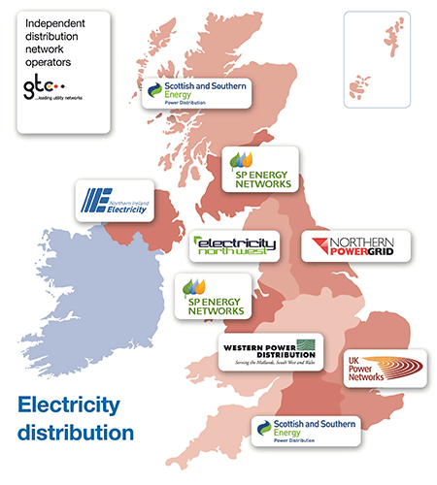

Image from Electricity Networks Association (ENA)

