Annex 1 – Consultation on getting an electricity connection responses and questions
  - We would like to hear the views of interested parties in relation to any of the issues set out in our consultation.

  - We would especially welcome responses to the specific questions which we have set out in our consultation and are replicated below.

  - If you have any questions on this document please contact:

James Veaney
Head of Connections and Constraint Management
Ofgem, 9 Millbank, London, SW1P 3GE
0207 901 1861
Connections@Ofgem.gov.uk

  - Responses should be sent, preferably by e-mail by 29 April 2016 to the address above.

  - Unless marked confidential, all responses will be published by placing them in Ofgem’s library and on its website www.ofgem.gov.uk. Respondents may request that their response is kept confidential. Ofgem shall respect this request, subject to any obligations to disclose information, for example, under the Freedom of Information Act 2000 or the Environmental Information Regulations 2004.

  - Respondents who wish to have their responses kept confidential should clearly mark the document/s to that effect and include the reasons for confidentiality. Respondents are asked to put any confidential material in the appendices to their responses.

  - Next steps: We will consider the responses to this consultation and these will be used alongside other evidence for our assessment of the ICE plans.

  - Each of the questions asked by this consultation is set out in the template below. Note that an editable version of this response template is available on our website as an associated document to this consultation.

  - Please ensure that you indicate the DNO to which your experiences relate.

  - When considering your responses to these questions, please consider your experiences, the actions that the DNO has undertaken or committed to undertake, and the actions that you consider it could reasonably undertake.

Response template
Question | Response
About you and your work
- What is the name of your company?
- In which DNO’s region do you generally operate (see Annex 2 for DNO map)? If you operate in more than one DNO’s region please indicate which DNO your responses to the following questions refer to.
- What type of connection do you generally require? And for each type of connection, how many connection applications, including total MVA (Mega Volt Ampere) of connections have you made in the past year? |  | Type of connection Total number of connections Total MVA of connections  Metered Demand Connections Low Voltage (LV) Work  High Voltage (HV) Work  HV and Extra High Voltage (EHV) Work  EHV work and above  Metered Distributed Generation (DG) LV work  HV and EHV work  Unmetered Connections Local Authority (LA) work  Private finance initiatives (PFI) Work  Other work
Consultation questions
- Do you consider there are constraints on the network in this DNO’s region?
If there are no constraints please do not answer the following questions.

- What impact have these constraints had on your ability to get connected to the network?
- To what extent has the DNO tried to find ways to help you get connected in constrained areas? For example:
  - To what extent has the DNO offered you more flexible and alternative connection arrangements alongside conventional firm connections? If not, then have they explained why not?
  - If the DNO does offer alternative arrangements, is the information provided sufficient to decide whether or not to go forward with the connection?
  - If the DNO does offer alternative arrangements, do you find the associated terms (eg. level of potential curtailment and certainty around maximum curtailment levels) acceptable?
- What information has the DNO shared with you on its work plan of activities designed to help enable connections in these areas?
  - How comprehensive has this information been?
  - To what extent has the DNO provided information on associated delivery dates of its work plan of activities?
  - Are you aware if the DNO is forecasting future levels of growth in the type of connections you require?
  - Are you aware of any plans the DNO has to invest in new network capacity where the network is constrained, to enable further customer connections? Have you been consulted on these plans? Has the DNO explored with you ways in which this could be funded?
- Please give details of any other activities you would expect the DNO to be undertaking to deal with constraints on their network.

Annex 2 - Map showing DNO licensee areas

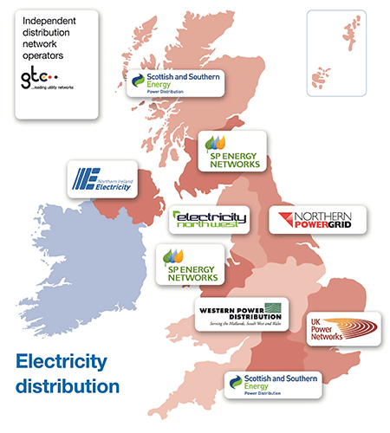

Image from Electricity Networks Association (ENA)

