Tim Aldridge
Ofgem
9 Millbank
London
SW1P 3GE
Name Helen Inwood
Phone 07795 354788
Fax 0121 336 5250
E-Mail Helen.Inwood@npower.com

6th December 2013

Dear Tim

Further consultation on restatement of 2009-10 data and closing out of the DPCR4 losses incentive mechanism

RWE npower welcomes the opportunity to comment on these proposals. This response is provided on behalf of the RWE group of companies, including RWE Npower plc, RWE Supply and Trading GmbH and RWE Npower Renewables Limited, a fully owned subsidiary of RWE Innogy GmbH.

Levels of Restatement

We are very concerned that the levels of restatement proposed in this consultation are providing a collective windfall gain to DNOs. Such excessive rewards for DNOs are totally unjustified. It is extremely unfair for customers to pay more through their bills for these windfall gains. While we accept that Ofgem are trying to look after the DNO interests in terms of allowing them to fairly restate positions on an incentive scheme, this activity clearly needs to be balanced with protecting the needs of customers.

The new methodology is proposing collective windfall gain rewards to DNOs ranging from £221m (vanilla option) up £264m (post 09-10 abnormal). This is on top of £113m already received for DPCR3 units. We cannot see how this additional cost to consumers can possible be justified, particularly given the fact that DNOs themselves have publicly stated that the DPCR4 losses incentive did not encourage them to make investment decisions which reduced losses.

Furthermore, it is important to recognise that every DNO signed up for the DPCR4 losses incentive scheme. The scheme out-turned at DNOs having a total penalty of -£235m. The table below shows the extent that this consultation changes the incentive reward / penalty for each DNO compared to the original un-restated value. (Green is £m benefit to DNO through restatement). Under the Vanilla Assessment, DNOs are receiving £474m more than they would have been entitled to under the DPCR4 incentive scheme they signed up for (Table 1).

The magnitude of these proposed windfall gains must be considered against DECCs recent announcement for DNOs to voluntary take action to under-recover revenue in 2014/15, resulting in a £5pa reduction in domestic DUoS fixed charges.
Table 1: Comparison of Original Scheme versus Restatement Options (£m)

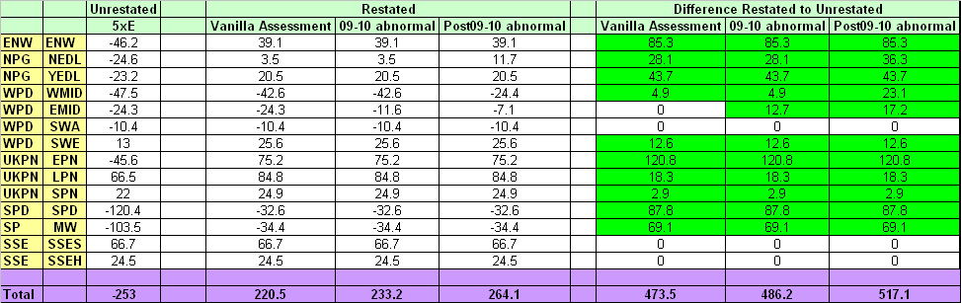

What is this restatement trying to achieve?

In the November 2012 consultation, Ofgem’s aim for the restatement process was to ‘give DNOs the opportunity to restore allowed positions to the proper level’. ‘The restatement must result in credible, technically feasible losses performance in 2009/10, that the licensee can justify would have been achievable’. In addition, Ofgem are keen to ensure that ‘the DNO is not unduly rewarded or penalised’ and ‘the need to avoid perverse outcomes’.

We believe these principles should still stand when considering this current consultation.

This restatement is unduly rewarding / penalising DNOs and not in the best interests of consumers

When faced with penalties in late 2010 from the DPCR4 losses scheme that they signed up to (i.e. prior to restatement), DNOs strongly argued that they have little or no impact on the losses incentive and that the settlement data used for losses is influenced by suppliers. For this reason, they concluded that the Losses Incentive Scheme did not encourage them to invest in low losses equipment.

In a letter to Ofgem on 26th August 2011, a joint letter from the Losses Incentive and Gross Volume Correction Working Group (signed by representatives from all 6 DNOs and ‘Big 6’ suppliers) expressed concern at the lack of influence that DNOs had on the losses incentive scheme:

The group concluded that

- “The Distribution Losses Incentive Mechanism, by using Settlement data that is both volatile and outside the DNOs’ control, no longer meets its objective of encouraging DNOs to achieve an efficient level of losses on their distribution networks”.

- “The DLIM results in windfall gains or losses for DNOs and exposes suppliers and customers to potentially large and unpredictable DUoS tariff movements”.

In addition, a number of individual DNOs, when supporting the removal of the losses incentive from DPCR5, made very clear statements around why the losses incentive was not encouraging them to invest in reducing losses (Appendix 1).

This therefore leads directly to the conclusion that they should not receive the large rewards being proposed in this consultation. We feel it is almost perverse that some DNOs, who have previously publicly stated that they have done little to deliver a reduction in technical losses, are now arguing that the restatement methodology proposed is giving them less money than they deserve and requesting the methodology to be reviewed to give them further benefit. The methodology is clearly not giving credible results. Such windfall rewards, and the resulting impact on consumer bills at a time where there are huge pressures on all market participants to reduce costs, cannot possibly be justified.

Our Proposed Solution

Over the last 3 years, the Industry has been looking at numerous methodologies in order to calculate a ‘fair return’ for DNOs on the DPCR4 losses scheme. We do not believe we are at this position. The industry cannot continue to spend inordinate amounts of time adjusting the methodology to get to the ‘proper level’ of losses. It is clear that the ‘proper level’ is that DNOs should neither be rewarded nor penalised through the losses incentive mechanism. For that reason, we have chosen not to comment on any of the proposed methodologies given in the consultation since none of them will achieve the required result i.e. an outcome that is gives credible values for the losses incentive.

As we have already stated our Nov12 consultation response, we believe that a pragmatic approach to this needs to be taken by Ofgem in order to protect the interests of consumers.

- The DPCR4 losses incentive scheme should be set to zero. However, if a DNO can show actual spend on their network to reduce technical losses, they should be rewarded for that additional spend. In addition, we are aware that they have employed a number of additional staff to deal with the data implications of this issue. Compensation should be provided for this also. We believe this provides a fair outcome for DNOs. They would neither benefit nor lose from the scheme that, by their own admission, has not encouraged them to actively manage their losses. This solution also provides a fair outcome for consumers who should not be paying for windfall gains by DNOs as a result of this restatement methodology.

Please note: This option should not apply to SPEN since there are other regulatory factors causing their penalty for losses. The value for SPEN should therefore be set at a realistic penalty, as determined by Ofgem (not zero).
OR

- The process reverts to the original DPCR4 losses incentive as signed onto and accepted by the DNOs as part of the DPCR4 Price Control.

DNOs have collectively received £317m to date (£401m excluding Scottish Power). This is already included in consumer bills.

- Under Option A, all DNO losses incentive (5xE) would be set to zero (excluding Scottish Power) such that they neither benefit nor are penalised from the incentive. DNOs’ would therefore return the monies already received (£401m excluding Scottish Power).

- Under Option B, no restatement of DNO losses incentive (5xE), DNOs would collectively return £570m and receive the penalty or reward that they signed up to through the DPCR4 incentive scheme.

The impact by DNO on the PPL term - monies returned to consumers – is shown in the table below:
Table 2: The PPL term if Options 1 or 2 are applied (£m)

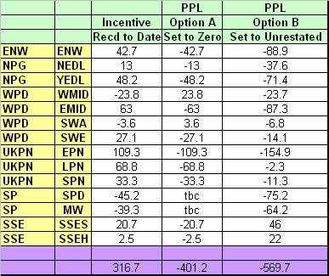

The DECC initiative to reduce £5pa from domestic bills

There are a number of government initiatives underway to reduce consumer bill in 2014. Included in this is DNOs undertaking a voluntary under-recovery in 2014/15 to allow DUoS bills for domestic customers by £5pa in 2014/15. We estimate the total under-recovery for DNOs taking part in this initiative will be -£110m, as shown in Table 3.

Table 3: Estimated revenue under-recovery by DNOs to meet the £5pa reduction in DUoS charges

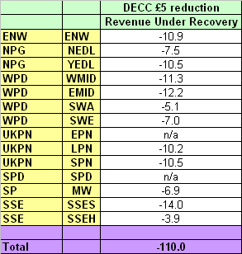

Comparing the above with the proposed reward to DNOs of £221m - £264m puts into perspective the extent of these unjustified windfall gains. At a time where there is considerable pressure on consumer bills, we cannot see how such rewards to DNOs can possibly be seen as credible, fair to customers and reflective of actual losses performance. Customers should not be expected to pay extra through their bills as a result of these windfall gains.

In Summary

We would urge Ofgem to consider whether or not the rewards and penalties proposed from the DPCR4 restatement methodology is justified and deemed to be fair to the consumer. If the results cannot be justified, we would request Ofgem to consider either setting the incentive scheme to zero to be fair to DNOs and consumers alike. Alternatively, there should be no restatement and the methodology that the DNOs signed up to under DPCR4 is enabled.

We would be happy to meet with you to discuss these options further.

Kind Regards

Helen Inwood
Network Charging Manager

(By email so unsigned)

APPENDIX 1

STATEMENTS MADE BY DNOS’ IN SUPPORT OF REMOVING THE DPCR5 LOSSES INCENTIVE

ENW
- ‘We do not believe that the DPCR5 Distribution Losses Incentive Mechanism will meet its objectives of encouraging DNOs to achieve an efficient level of losses on their distribution networks since the outcome is largely outside of their influence’

Northern Powergrid
- ‘The evidence is now overwhelming that the mechanism cannot operate to incentivise a rational DNO to take any action to minimise losses because the mechanism depends on data that is dominated by the behaviour of suppliers and has almost nothing to do with the steps taken by Distributors’.

SP Energy Networks
- ‘We do not believe that the existing losses mechanism is effectively incentivising DNOs to reduce losses.
- There is therefore very limited incentive on DNOs to spend to reduce losses’.

WPD
- ‘We do not believe the current incentive system is incentivising DNOs to reduce losses. The mechanism is too unpredictable and is outside the control of DNOs,to enable any rational decision on investing in low loss equipment to be made.

- One further option would be to close out DPR4 by merely reversing gains/losses to DNOs, in effect leaving DPR4 losses at a neutral position. This would seem to be the right thing to do for customers; in the absence of hard evidence that DNOs investment plans have been altered by the losses incentive, it would seem perverse that DNOs have gained or lost financially as a result of the incentive’.

