James Veaney
Head of Distribution Policy
Ofgem
9 Millbank
London
SW1P 3GE
October 31st 2013

Dear James,

Response to consultation on RIIO-ED1 customer service and connection incentives
Consumer Futures welcomes the opportunity to contribute our views on these issues. Our submission is entirely non-confidential and may be published on your website.
We provide, below, answers to the questions raised in the consultation. In general, we consider that Ofgem’s proposed approach is sensible and proportionate and we agree with the majority of the ‘minded to’ positions set out in the consultation.
We would, however, highlight two areas where we think further consideration is necessary.
Firstly, we consider that more consideration be given to the inclusion of different approaches to gathering information from consumers as part of the customer satisfaction survey. All DNOs report that consumers are making increasingly more use of email, text messages and social media when contacting them, and we have welcomed the steps they are taking to respond to consumer choice in this area.
It therefore seems reasonable that the customer satisfaction survey should also reflect consumer choice of channels when gathering information.
Secondly, we consider that a more detailed approach should be taken in relation to the Incentive on Connections Engagement (ICE). Other parts of this consultation examine quite detailed metrics; in contrast, the ICE only proposes a penalty for DNOs which do not produce a plan for their areas.
We would suggest that there is more scope for development of the detailed measures which should be covered in DNO plans, and we explore this in more detail below.

If you would like to discuss any point in further detail please get in contact.
Yours sincerely,
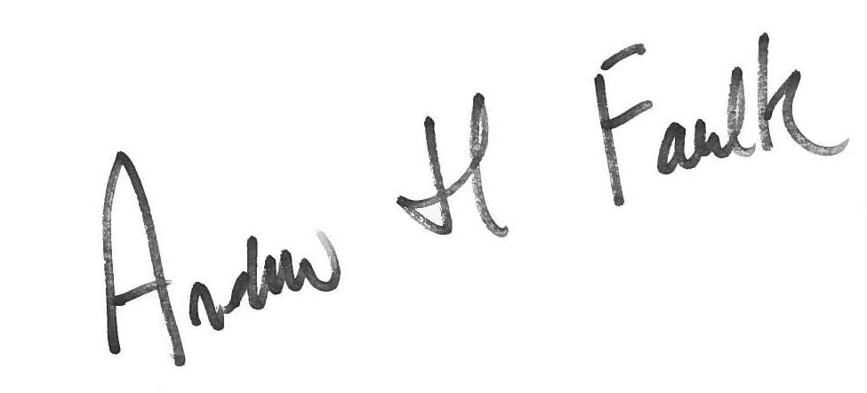
Andrew Faulk
Policy Manager
Andrew.Faulk@consumerfutures.org.uk
0141 227 1842

Customer Satisfaction Survey

Q1 should we set common targets for all DNOs?
Yes. We agree both with the proposition and with Ofgem’s rationale which supports it.

Q2 Should we set common targets for all customer categories?
Yes. We agree both with the proposition and with Ofgem’s rationale which supports it.

Q3 How should we calculate the target and the maximum reward / penalty score?
We agree with the proposal of benchmarking DNOs performance against other industries, while taking into account current DNO performance.
We recognise that DNOs already deliver a high standard of performance than many other industries, including those in the utilities sector. We therefore agree that setting the benchmark at the top quartile is challenging but achievable, especially given DNOs satisfaction ratings have improved over recent years.

Q4 How should we calculate the incentive rate?
We are not able to comment on the detailed calculations, but we would emphasise that the scale of the incentives or penalties should be proportionate to DNO’s costs.

Q5 What level of influence should we place on calls that are unable to reach a DNO?
We consider that it is most important for consumers that they are able to contact their DNO to report power cuts during severe weather. DNOs should be expected to make arrangements for increased call volumes during these periods.
At the same time, we agree it is clearly not reasonable to penalise DNOs for not responding to calls they did not receive because of a problem for which the telephone operating company was responsible.
We therefore agree with Ofgem that call penalty exposure should not be capped, but that consideration should be given to calls not received for reasons outwith DNO control. As above, we are not able to comment on the precise figures used to set penalties, other than that they should be proportionate to DNO turnover; it should not, for example, be cheaper for DNOs to pay the penalty than to invest in telephone systems.

Complaints Metric

Q6 How should we calculate the target and the maximum penalty score?
Q7 How should we calculate the penalty incentive rate?
We agree that the ‘minded to’ position encourages improvement among less well performing DNOs, while recognising that the industry as a whole already performs relatively well. In addition, it seems sensible to use the same approach for ED1 as has been applied for GD1.

Time to Connect Inventive

Q8 Do you agree with our ‘minded to’ position to set common targets for all DNOs?
Yes. It seems reasonable to expect that, for lower voltage connections, service standards should be the same across GB.

Q9 Should we set targets for different types of connection?
Yes. It seems reasonable for low voltage connection times to vary depending on type.

Q10 How should we split the reward across the four elements of the incentive?
We recognise the tensions between different elements of this incentive. We would suggest that, given the uncertainty, it might be appropriate to review this incentive after it has been in operation for (say) four years, given that this approach is being proposed for the target / maximum reward score (Q12).

Q11 How should we calculate the target and the maximum reward score?
We agree with the ‘minded to’ position, so that rewards encourage improvements on the current industry average.

Q12 How should we increase the target / maximum reward score during the period?
Given the uncertainty, the ‘minded to’ position seems sensible.

Incentive on Connections Engagement

Q14 Do you agree with splitting the penalty equally across the market segments?
We understand and agree with the rationale for applying this incentive only to those market segments that do not pass the Competition Test.
However, it seems from the background information provided that this part of the consultation is different from the others.
Whereas earlier sections set out specific proposals, this section proposes a penalty on DNOs if they do not produce detailed plans for engagement with remaining market segments. It does not offer an opportunity for stakeholders to comment on what those detailed plans might cover. Again in contrast with other sections, there is a risk that plans will be prepared and implemented without any ongoing incentives for DNOs to improve the service they offer.
Further, we recognise that the services that different consumers will value across different parts of the major connections sector will vary. For example, large housing developers (or large electricity generators) are likely to have in-house expertise as they will go through the connections process regularly. Conversely, smaller, community level generators are likely only to connect once.
It is reasonable to expect DNOs to offer a more flexible service for the latter group of consumers, and some DNOs have already highlighted to us their approached of discussing different options available to smaller generators in constrained areas. These options include reducing the scale of generation, or of having a contract which may limit the amount which can be fed into the grid at certain times. It may therefore be appropriate to tailor incentives towards different groups.
We would therefore suggest that an overall approach should be taken:
- The views of stakeholders based on their current experiences should be gathered to inform the discussion. Following from the above, it would be particularly useful to seek views from larger organisations which have contact with more than one DNO, such as housing developers, or from umbrella organisations, for example those representing smaller scale renewable energy generators, which are able to synthesise experience from a number of different connections across different areas.
- This information gather would provide a better basis both for DNOs to prepare plans, for stakeholders to contribute to their development, and for Ofgem to assess them.
The end aim – as in other sections of this consultation – should be to move towards a more consistent approach with appropriate metrics, incentives and penalties built in to finalised ED1 plans.

