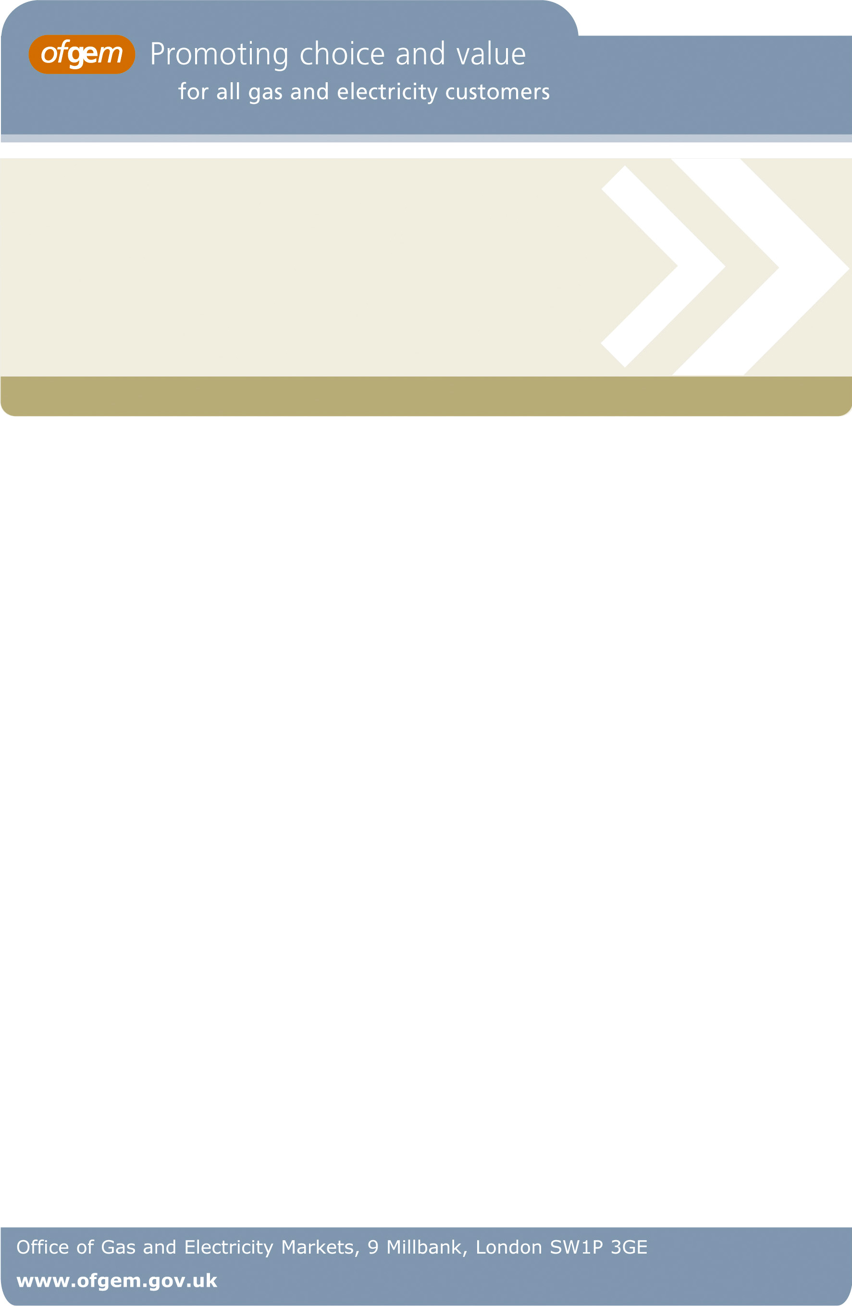
Annual reports
Overview:

This section contains annual reports providing information in respect of the following periods of the Renewables Obligation:
• First period (1 April 2002 – 31 March 2003)
• Second period (1 April 2003 – 31 March 2004)
• Third period (1 April 2004 – 31 March 2005)
• Fourth period (1 April 2005 – 31 March 2006), and
• Fifth period (1 April 2006 – 31 March 2007).

The annual reports incorporate the following information on both the Renewables Obligation, the Renewables Obligation Scotland and the Northern Ireland renewables Obligation:
• how licensed electricity suppliers complied with their obligations
• the number of Renewable Obligation Certificates issued, and
• the number and type of generating stations accredited.

Target Audience: These documents provide information to parties with an interest in the Renewables Obligation.

.

Office of Gas and Electricity Markets
Promoting choice and value for all gas and electricity customers
Date of Publication: 03 March 2008

Contact name and details: Rebecca Langford

Tel: 0207 901 7141

Email: Rebecca.langford@ofgem.gov.uk

Team: Environmental Programmes

