Alex Thorne
Social and Environmental Affairs
Ofgem
9 Millbank
London
SW1P 3GE

by email

Tel: 0131 668 8810
Fax: 0131 668 8788
email: malcolm.bangor-jones@scotland.gsi.gov.uk

20 December 2002

Dear Mr Thorne

ELECTRICITY ACT SCHEDULE 9 STATEMENT

Thank you for providing Historic Scotland with the opportunity to comment on your consultation exercise concerning Schedule 9 of the Electricity Act 1989.

General remarks

1. The Electricity Act names the Ancient Monuments Board for Scotland and the Historic Buildings Council for Scotland as statutory consultees. There was, however, no consultation with these bodies before this provision was made, nor with Historic Scotland’s predecessor (which, as Historic Scotland does currently, provided the secretariat). Unlike most other bodies named in the Act, these two bodies are purely advisory. They provide advice to Scottish Ministers on the historic environment and, in particular, the functions of Scottish Ministers under the relevant heritage legislation, particularly the Historic Buildings and Ancient Monuments Act 1953, the Ancient Monuments and Archaeological Areas Act 1979, and the Planning (Listed Buildings and Conservation Areas) (Scotland) Act 1997.

2. The executive functions of preserving the built heritage set out by these and other statutes are performed for Scottish Ministers by Historic Scotland, an Executive Agency within government. Historic Scotland is thus not a statutory body, being a creation of administrative convenience. Since the passing of the Electricity Act, it has been Historic Scotland (and its predecessor body, Historic Buildings and Monuments) which conducted liaison with the electricity companies over Schedule 9. Early on, we reported to the two advisory bodies that we would be doing this and undertook to report matters of substance as necessary. Since then, there has been little need to make reports to either AMB or HBC, and in all cases these have been about specific cases rather than generalities.

3. Historic Scotland is aware that the provisions of Schedule 9 lack clearly defined sanctions for non-, or poor, performance on the part of licence-holders. However, in our experience of working with the two major vertically-integrated Scottish power companies and also the smaller players in Scotland, including the nuclear sector, this lack of ultimate sanction does not seem to have inhibited the development of a conservation-aware culture within the relevant sections of the companies. To some extent, we would see this development as driven by commercial factors. Now that these companies report publicly to shareholders on their environmental performance, breaches of Schedule 9 obligations and statutory breaches are regarded as detrimental to the companies’ public reputations and, hence, market worth.

4. It has been Historic Scotland’s consistent view that the Schedule 9 Statement itself should form the bedrock of individual company standards. More important, we have pursued a consistent line with the companies, in arguing for the Schedule 9 Statement to be a general statement of principles as a starting point for procedural development. For us, the key is sound planning and operational procedures which depend upon the Schedule 9 Statement for validity, but which deal much more closely with the detail of day-to-day company practice. We feel this model works well. It minimises the need for the bureaucratic and time-consuming process of regular formal revision of Schedule 9 Statements, and allows staff on both sides to focus on achieving results in terms of conserving the environment.

Issues for consideration, as set out in the consultation paper

4.10 Historic Scotland confirms that the Schedule 9 process does have an important role in focussing attention on the environmental dimension of works which fall outwith the need for planning consents and other statutory regulatory processes.

4.14 Historic Scotland agrees that emissions and related matters appear to be well dealt with under statutory requirements, and can see merit in the Schedule 9 process being more closely focussed on the issues of built and natural heritage as set out here. However, we would expect that these issues would be defined, by all partners in the process, in a more holistic sense. Current thinking in our fields emphasises connected-ness, with concepts such as habitats and landscape character playing a greater role than when the Act was drafted, and the role of the individual species or site possibly less dominant than once it was. This simply requires conceptual awareness, not statutory revision.

4.16 Historic Scotland sees Schedule 9 Statements operating best as a general statement of principle, and as such they should not require frequent updating – 5 years would be the correct order of interval, while less than 3 years would seem too often.

4.19 The major Scottish companies already report in this way, and Historic Scotland would commend this as a general principle.

4.24 In years past, a degree of co-ordination was provided by the industry, by way of occasional conferences. We are aware of meetings in which we took part organised by the Electricity Association, especially the interest section dealing with wayleaves and kindred matters. Fragmentation, fiercer competition and increasing tightness of operating budgets appears to have put paid to this type of gathering, and there might well be a useful role which could be performed by Ofgem in facilitating industry-wide co-ordination. The idea of an annual workshop on Schedule 9 issues would be welcome. We would recommend that each meeting might focus on a small number of current issues, rather than trying to cover the entire scope of Scheduled 9 activities at a sitting.

4.27 In respect of Schedule 9, Historic Scotland is content to continue to perform the functions it has performed for over a decade. We do not envisage that the changes under discussion in respect of the advisory bodies will have any impact on our ability in this respect. We would also point out that the Consultation Document appears to misrepresent the situation in Wales: HBC Wales rather than Cadw is the nominated body in the Act.

The views set out above were communicated to the Ancient Monuments Board for Scotland at its meeting on 6 December. We intend to bring the issue to the attention of the Historic Buildings Council for Scotland in due course.

Yours sincerely

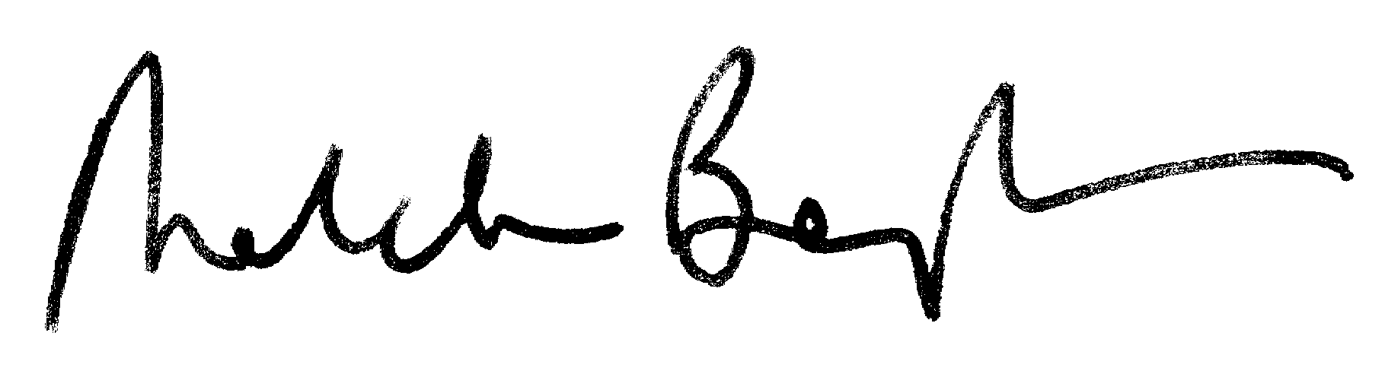

DR MALCOLM BANGOR-JONES
Heritage Policy Manager

