

Lars Even Rognlien
Distribution Policy Manager
Regulation & Financial Affairs
Office of Gas & Electricity Markets
9 Millbank
LONDON
SW1P 3GE

Lars.rognlien@ofgem.gov.uk

28 February 2003

Dear Mr Rognlien,

“”ELECTRICITY DISTRIBUTION LOSSES: A CONSULTATION DOCUMENT”

The Scottish Council for Development and Industry (SCDI) is an independent membership network, which strengthens Scotland’s competitiveness by influencing Government policies to encourage sustainable economic prosperity. It is a broad-based economic development organisation, with membership drawn from Scottish business, trades unions, public agencies, educational institutions, local authorities, and the voluntary sector. SCDI has had a strong interest in energy policy for many years and I write to offer its views on the issues set out in the above consultation paper.

SCDI accepts that a reduction in electricity lost during transmission will reduce the amount of electricity production required, leading to environmental benefits in terms of reduced pollution. It also notes Ofgem’s suggestion that transmission and distribution losses in Great Britain currently amount to a cost of between £600-700 million per annum, a significant cost that has to be borne by the consumer, and which should therefore be minimised as far as is possible.

However, SCDI does not believe that Ofgem's preferred option, focussing on the delivery of outputs by Distribution Network Operators (DNOs), is appropriate (paragraph 1.18). Sending locational signals for future development, as this option would do, risks hindering the encouraging progress on renewable energy by making it less attractive to export “clean” electricity from Scotland to markets in the south of England. While it may be true that transmission and distribution losses represent a cost even for electricity generated from renewable sources, the environmental impact of such losses is significantly lower than other forms of generation, given its carbon-free nature.

It should be borne in mind that the best way to reduce climate change emissions due to electricity generation, and indeed transmission losses, is to use less electricity in the first place. Research for the Energy Savings Trust suggests that improved energy efficiency in the UK could deliver a higher carbon saving than even a significant shift to renewable energy.

There is evidence that the Climate Change Levy, although far from perfect, is beginning to drive change in energy use in the business sector. Much more needs to be done, particularly with efficiencies in domestic electricity consumption becoming arguably less attractive and more elusive as prices to the consumer are driven down by competition over time.

SCDI therefore believes that Ofgem should adopt the second option set out in the consultation paper (paragraph 1.17). In other words, the existing incentive framework for DNOs should be maintained, with attention focusing on providing appropriate incentives to consumers to enhance their energy efficiency.

I trust you will find SCDI’s views useful in taking the consultation forward.

Yours sincerely,

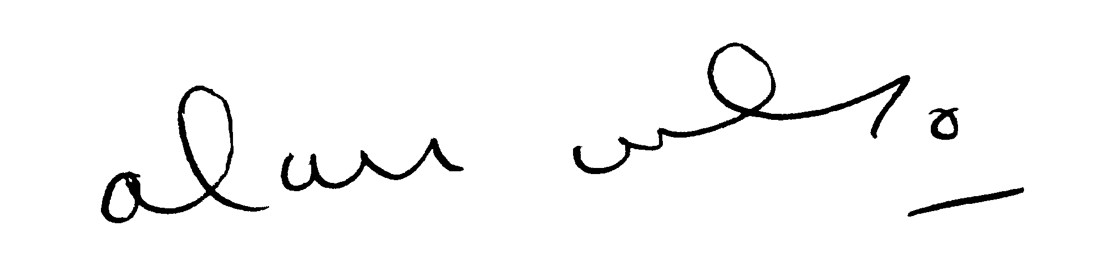

Alan Wilson

Chief Executive

