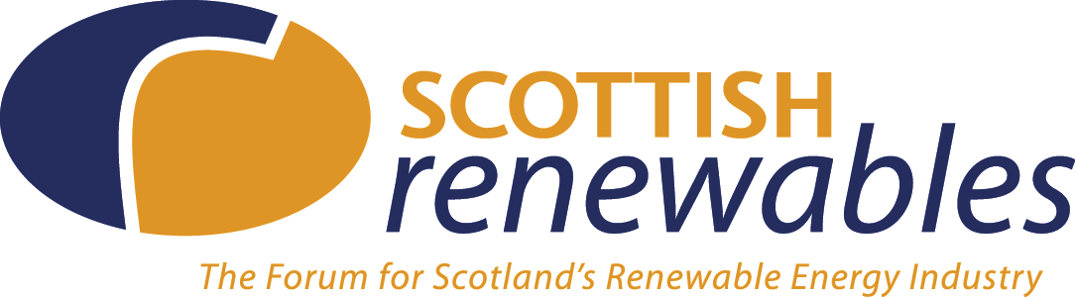

David Halldearn
Director, Scotland & Europe
Ofgem
9 Millbank
London
SW1P 3GE

30 July 2026

Dear David,

The Connection & Use of System Code under BETTA – a Scottish Renewables consultation response

Many thanks for providing the opportunity to comment on the above document, and thanks also for the extension of the consultation timescale, which has enabled us to develop a more robust reply to the issues raised.

Scottish Renewables supports the view that a GB Connection and Use of System Code (CUSC) will be needed if BETTA is to function correctly. Rationalisation of agreements relating to connection and use will assist in providing a clear and transparent framework for operating in Scotland

Also, Scottish Renewables thinks it appropriate that the GB system operator be responsible for contracting with users of the transmission system for connection to, and use of, the system. In saying this, however, we would note that generators and developers will continue to have contractual arrangements with system owners, so any GB CUSC must ensure different contractual arrangements are supportive of each other.

However, any GB CUSC needs to be developed in light of the experience of generators and users across the GB. Scottish Renewables is particularly concerned that it takes into account the needs of small generators in Scotland, many of whom operate on the cusp of the 132/33 KV boundary that separates transmission and distribution. How the needs of such system users are recognised and accommodated will be critical in the successful establishment of any GB CUSC.

Development of any GB CUSC that complicates, rather than simplifies connection for smaller generators will therefore be the necessary benchmark that the GB CUSC must attain.

In terms of issues raised, Scottish Renewables appreciates that much will depend on the detail published in the 2nd and 3rd related consultations. We have therefore sought to highlight overarching concerns and to provide pro-active and constructive comments on these key issues raised, in anticipation of the release of further detail.

Appendix One, enclosed below, includes information on the what we feel are the key relevant points raised through the consultation document. I trust that these comments will assist you in taking on board the views of the renewables industry in Scotland, and I look forwards to receiving the next consultation on this topic. If you have any enquiries as a result of the points raised, please do not hesitate to get in touch.

Yours sincerely,

Maf Smith
Business Manager
APPENDIX ONE: The Connection & Use of System Code under BETTA – response from Scottish Renewables Forum

Ofgem/DTI consultation on a CUSC to apply throughout GB

Single point of contact
Para 4.20
Regarding the proposal about creatioin of a “one stop shop” for connection. We would note that users wishing to connect in Scotland currently go to the relevant Licensee (SP or S+S). Under the new arrangements it appears that users will have to choose whether to apply to the DNO (for connections at voltages less than 132kV) or to the GB system operator (for connections at 132kV and above). Several questions arise:
Who do you apply to if you’re connecting to a 132/33kV substation?
Will users end up paying for 2 feasibility studies – one with GBSO, one with the DNO?
Will users still be able to obtain informal information on which is likely to be the best option?

The document notes that the lack of a “one-stop-shop” in E&W does not appear to be a problem, but we would question whether there are any windfarms in E&W connected at 275kV (which is the lowest transmission voltage compared to 132kV in Scotland)?

While creating a single point of contact has a ring of efficiency, we would question whether this can be realistically be achieved. Much will depend on the attitude and work of the owner, and the system operator will depend on the owner for information about available capacity etc. It could easily be that extra steps and cost are introduced into the system in the name of apparent simplicity. We would urge caution from Ofgem in defining how small generators will work with the SO-TO distinction.

Principles of ownership
Para 5.17-5.23
Scottish Renewables is of the view that the English-Welsh CUSC cannot be incorporated unchanged into a GB CUSC, because this would fail to recognise differences within the Scottish market. Ofgem/DTI must ensure that any GB CUSC is able to recognise that there are currently different transmission levels in Scotland, so that users of the system in Scotland are not penalised. We therefore support the view that the CUSC should be generalised to ensure that it applies to a GB wide picture.

Small generators under the GB CUSC
Para 5.32-5.35
Scottish Renewables welcomes the fact that Ofgem has recognised that in Scotland, there is significant levels of transmission connected in Scotland that is licence exempt, and connected down to 5MW. We await further consultation on this issue.

However, we would urge that provision be made under a GB CUSC that ensures such generators are not penalised, so would invite consultation to focus on how to ensure the Scottish situation can be supported, and smaller generation accommodated under a future GB CUSC.

A GB CUSC must not impose a requirement to provide mandatory ancillary services on any small (or medium) generators connected to the transmission network in Scotland. As a general point the grid code should not force any renewable generators (whether connected to the Distribution or Transmission network) to meet the requirement to supply mandatory ancillary services.

