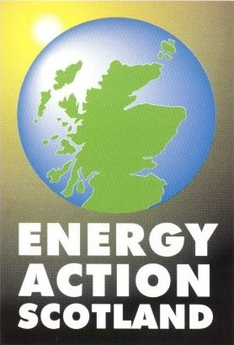

NK/JM/3607

13 February 2003

Gill Whittington
Chief Operating Officer
Office of Gas and Electricity Markets
9 Millbank
London
SW1P 3GE

Dear Ms Whittington

Ofgem Corporate Strategy 2003-2006

Please find attached Energy Action Scotland’s response to the above noted consultation document. In line with normal Energy Action Scotland policy, the paper is not intended to be a confidential response and as such may be made publicly available.

Yours sincerely

Norman Kerr

Norman Kerr
Development Officer

Company limited by guarantee.
Registered in Scotland No. 101660
Charity No. SCO 09280
Ofgem Corporate Strategy 2003-2006

Energy Action Scotland (EAS) welcomes the opportunity to comment on the Ofgem Corporate Strategy 2003-2006.

As the charity with the remit for ending fuel poverty in Scotland, EAS’s interest is focused on matters relating to low income and vulnerable customers. We are therefore supportive of Ofgem’s plans to tackle fuel poverty and to continue to implement its Social Action Plan.

We note Ofgem’s comment that fuel poverty cannot be solved through domestic fuel price alone. EAS believes that fuel poverty is caused by a combination of 3 factors: high or fluctuating domestic fuel price, poor house condition and low disposable household income. EAS agrees that all areas must be addressed. However, EAS is concerned about the claims of numbers taken out of fuel poverty in recent years by means of price reductions alone. If prices were to rise, particularly in times of global crisis, then many households may well move back into fuel poverty. EAS advocates a permanent end to fuel poverty.

It is therefore essential in our view to continue energy efficiency improvements to properties through schemes such as the Energy Efficiency Commitment (EEC). However, EAS believes that EEC, and other energy efficiency grant schemes, must be allowed to deliver additional measures, such as those which can improve the energy efficiency of solid wall and other non-traditional construction type dwellings. Around a third (29%*) of the Scottish housing stock does not have cavity walls and around a fifth (22%*) does not have loft space (*source: Scottish House Condition Survey 1996) and therefore cannot benefit from cavity wall or loft insulation, which are the current main measures delivered by EEC programmes.

EAS also believes that EEC must work with greater coordination in relation to other energy efficiency grant schemes. This is particularly important when dealing with blocks of flats with mixed tenures in order for the maximum number of measures to be delivered for the benefit of all householders.

EAS sees energy advice as essential when delivering assistance to low income and vulnerable householders in particular. We would want to see energy advice become a compulsory part of all energy efficiency schemes including EEC.

Prepayment meters (PPMs) continue to be a controversial matter. EAS is concerned that low income and vulnerable customers be given a choice of payment method. We also want to see clearer evidence that full information is provided to customers which makes clear the premium to be paid by PPM users in relation to other payment methods.

EAS supports the further development of alternatives to PPMs, such as smart meter technology.

EAS sees it as essential, that Ofgem’s plans, and the Social Action Plan in particular, work closely with the UK Fuel Poverty Strategy and the fuel poverty strategies of the devolved administrations. This is important in Scotland, where energy efficiency is a matter devolved to the Scottish Parliament, but energy market regulation and pricing – as well as fiscal matters such as income and benefits – are matters reserved to the UK Government at Westminster. Coordination across departments is therefore essential.

Energy Action Scotland is happy to have its response made public.

