
Kings Buildings
Smith Square
London SW1P 3JJ

Telephone: 020 7834 3399
Fax: 020 7834 4469

Direct phone: 020 79636718

Direct fax: 020 7834 8587

e-mail: siddallr@cia.org.uk

www.cia.org.uk
Dear Ms Whittington,
29th January 2003
Ms Gill Whittington
Chief Operating Office
OFGEM
9 Millbank
London
SW1P 3GE

OFGEM PROPOSED CORPORATE STRATEGY 2003 – 2006

The chemical industry continues to be the largest user of electricity in the manufacturing sector, accounting for approximately 20% of electricity and 30% of gas, equivalent in each case to about 5% of all UK supply. The sectors’ combined gas and electricity bill is in the order of £1 billion. In addition to its consumption of energy for fuel and power, the industry uses energy as an essential feedstock for many chemical processes, which adds value to the basic raw materials. We therefore welcome the opportunity to comment on OFGEM’s proposed corporate strategy for 2003-2006.

Making markets work successfully

CIA strongly supports OFGEM’s continued allocation of resources in this area.

We are particularly concerned about the wholesale part of the supply chains. In gas, we continue to believe that an independent enquiry into the operation of the wholesale market is required and therefore strongly support OFGEM’s efforts to work with the DTI to ensure that offshore arrangements encourage a competitive gas wholesale market. In electricity, we welcome the great improvement NETA has made with regard to industrial competitiveness and believe this must not be overturned by parties that might wish to abandon NETA for reasons of special interest. We strongly support the arguments for BETTA and believe OFGEM should do everything possible to accelerate its introduction. At the European level, we strongly support OFGEM’s continued work in market liberalisation. With regard to Industry Structures, we have been concerned for some time now about the considerable amount of consolidation and re-integration taking place in both the gas and electricity supply chains. We believe this to be bad for competition and urge OFGEM to allocate more resource in this area in order to reverse the trend and consider in greater depth whether future proposed mergers are genuinely in the interests of customers.

Regulatory monopoly business effectively

CIA supports OFGEM’s aims of properly regulating the monopoly networks and ensuring economic and efficient network investment. However, we do not agree that the current reform process, which aims to create capacity markets in gas and electricity, is the best means of achieving these objectives. We believe there is great potential to add complexity and cost to the supply chains, with little real benefit to customers. We believe OFGEM should significantly scale back the amount of resource it devotes to this area; and that it should modify it’s strategy to one of (as far as possible) simple administrated arrangements that will encourage low transaction costs and stability of changes. We consider that, because network investment is critical to the long-term health of the chemical industry, decisions about it cannot be left entirely to market mechanisms. We believe the regulator must apply direct pressure to the monopolies to ensure sufficient investment. We ask OFGEM to review, in detail, the effects of the first long term gas auctions, with regard to the resources and arrangements that will be needed to attract secure and competitive gas suppliers in the medium to long term.

Securing Britain’s gas and electricity suppliers

CIA fully supports OFGEM’s work in this area and believes that liberalised markets are the best guarantee of security of supply. We support OFGEM’s allocation of resource to market monitoring in order to provide early warning of any failure to respond to market signals. CIA believes this approach will result in much better outcomes for customers than a strategy of maintaining security of supply by a return to an interventionist energy policy.

I trust these views are helpful and shall be pleased to discuss any aspects in greater detail.

Yours sincerely,

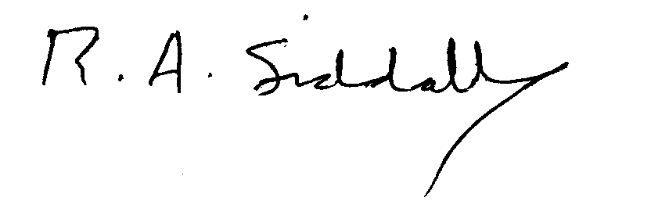
Robert Siddall
Utilities Policy Manager

