

Nigel Nash
Head, Market Infrastructure
Ofgem
9 Millbank
London
SW1P 3GE

30 July 2026

Dear Nigel

Erroneous Transfer Customer Charter Implementation Review

Thank you for the opportunity to respond to Ofgem’s review of the initial stages of implementation by suppliers of the Erroneous Transfer Customer Charter.

This review has allowed us to gain a good understanding of how the industry is meeting the requirements of the Charter. Below we have set out some additional comments and proposals in light of this review:

- We are pleased that Ofgem has accepted the energywatch view on automatic compensation to consumers for breaches of the Charter. However, we do believe that this right should be extended to include compensation for causing an Erroneous Transfer in the first place. Often the ET in itself can be a great source of worry and inconvenience to consumers and it would be inconsistent if compensation were payable for those very reasons for any breach of the Charter, but not forthcoming for causing the ET.

There are still a significant number of people subjected to a transfer against their will or, as evidenced by the figures in the Ofgem Review, a failure by companies to communicate between themselves or put in place processes to get the consumer returned to their chosen supplier. The acid test has to be “has the consumer been returned in a timely fashion?” There can be no marks for trying, only for success. For this reason, we believe that compensation payments should be graduated on a case-by-case basis according to the aggravation caused or the length of time taken to put the ET right. The greater the supplier error or the longer it takes to rectify, the higher the compensation.

- We welcome the encouraging signs emerging from the statistical analysis but regard the Charter as only having been a qualified success to date. We are particularly concerned at the percentage of consumers not being returned to their chosen supplier within a reasonable period of time or at all. This undermines the purpose of the Charter and has to be viewed as one of the criteria as to whether it is fit for purpose. Notwithstanding the efforts that industry has made to date, we consider that it has a lot to prove to clearly demonstrate an acceptable level of compliance.

- We note the timescales set out in your document to further review industry performance and, if necessary, to commence the process of introducing regulated measures. We believe that it would be more prudent to begin the lengthy process of drafting the Overall and/or Guaranteed Standards or the Licence Condition much sooner than the proposed September 2003 review date. This would concentrate companies’ minds that Ofgem mean business in the event of unacceptable performance. It would also ensure that mandatory standards could be put into effect immediately rather than be further delayed by the consultation/legal process, if the standard of supplier compliance with the Charter was unacceptable.

- We accept the need for ongoing monitoring of performance through supplier returns to Ofgem and shall be undertaking a similar exercise with our own complaints data. However, rather than set a further review in tablets of stone for September 2003, we believe that any persistent failure to improve upon current levels of compliance should trigger a review straight away.

- We echo your comments on companies using the escalation process to greater effect and call upon companies to follow this rather than allow an unacceptable level of consumers to be delayed or not returned to their chosen supplier.

- We are still discovering from front line staff across the Regions that some suppliers are re-registering customers rather than using the Erroneous Transfer Charter process. Although this may speed up the customer’s return, it does not adhere to the spirit or letter of the Charter and customers can find themselves paying for a short period of supply from an unwanted supplier. This practice also has the potential of being used to circumvent the Charter process and the payment of any automatic compensation.

- From complaints that we have received, we are also aware that one major supplier, when the losing supplier, is still insisting that their customer call MPAS or Transco to find out who the gaining supplier is and then insists that customer call the gaining supplier to request to be returned. This is a clear Charter breach.

If you would like to discuss any aspect of our response please do not hesitate to call me on 020 7799 8362.

Yours sincerely

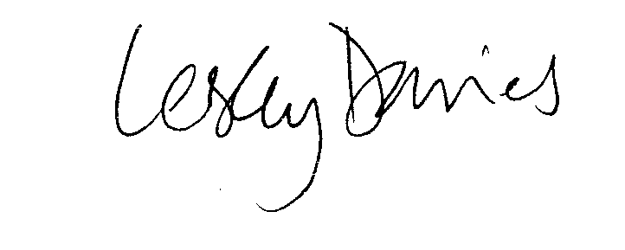

Lesley Davies
Director, Policy and Research

