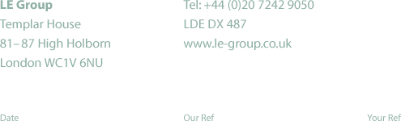

2 July 2002

Ben Woodside
Strategy and Corporate Transactions Manager
Ofgem
9 Millbank
London
SW1P 3GE

Dear Ben

LE Group’s proposed acquisition of SEEBOARD

Here are LE Group’s (LEG) comments on the issues raised in your consultation paper.

Competition in electricity and gas supply

Electricity supply

Domestic customers

We agree with Ofgem that competition in all parts of the domestic electricity supply market is now well established. It is our view that the electricity supply market is a national one. Our experience in our original LE and SWEB franchise areas is that there is considerable price-based competition, as a result of which there has been a large and continuing decline in our market shares in those areas. We agree with Ofgem that our proposed acquisition of SEEBOARD will not have the effect of significantly lessening that degree of competition

Non-domestic customers

We agree with Ofgem that the increase in our share of the non-domestic electricity supply market will not significantly lessen competition.

Gas supply

LEG’s share of the gas supply market, which we agree is national one, will remain small after the transaction. The transaction will however help create more effective competition with Centrica, which has been using its dominance in the gas market to acquire a dominant position in the energy supply market as a whole.

Competition in electricity generation

We agree with Ofgem that the increase in LEG’s share of the generation market will have no material effect on competition in that sector. It should be noted that LEG will acquire only a minority holding in Medway Power as a result of the transaction. While LEG will remain a vertically integrated company, it operates in markets for generation and supply in both of which there is effective competition and is therefore unable to use its position in one to exercise market power in the other. We believe that there will remain a liquid market for the sale and purchase of short and long term generation contracts, a market in which we intend to remain active.

Electricity connections and metering

The licensed distribution businesses within the enlarged LEG will continue to work with Ofgem to agree the conditions under which customers could consider the option of having some connections work carried out by third parties. LEG does not believe that the transaction will have a material effect on the choice of connections providers.

Electricity distribution

LEG understands Ofgem’s stated policy towards distribution mergers and will expect to consider licence modification proposals following completion of the acquisition, which itself depends on clearance by the relevant competition authority.

Yours sincerely

Denis Linford
Group Head of Regulation

