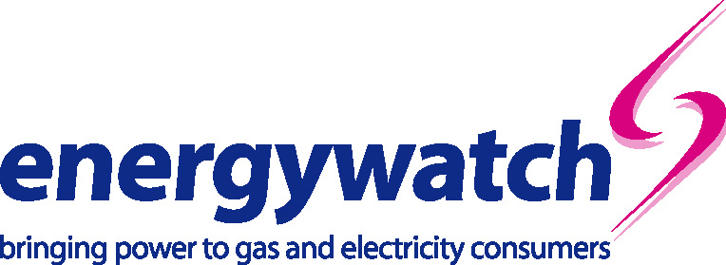

Tuesday, 2 July 2002

Ben Woodside
Strategy and Corporate Transactions Manager
Ofgem
9 Millbank
London
SW1P 3GE

Dear Ben,

London Electricity Group plc’s proposed acquisition of CSW Investment
energywatch considers there are sufficient concerns to investigate further the need for undertakings regarding London Electricity Group’s future market conduct before the merger is cleared. here are some important consumer concerns related to the combined market shares in connections and the non-domestic supply markets that warrant further investigation. We believe that there is a strong case for some undertakings to be given by London Electricity Group. For example, they might undertake not to make further mergers in at least the connection and non-domestic sectors for a number of years (depending on the development of competition in these markets).

Dominance in the energy markets
energywatch has long held concerns about the high levels of concentration in the regional domestic supply markets and the subsequent reduction in the choice of supplier for consumers. We are now concerned that this merger creates a player with a high market share in the non-domestic electricity supply sector. This merger increases the scope for oligopolistic pricing behaviour by the remaining suppliers.

Ofgem’s analysis demonstrates that the proposed merged company would account for a quarter of total low voltage connections and domestic connections and a third of total high voltage connections to the electricity distributions networks. This is equivalent to around 30 per cent of total connections revenue across all the electricity distribution businesses. energywatch has some concerns over the level of control that the proposed merged company will have in the connections market. Particularly in light of the fact that not all aspects of the

connections market are competitive (i.e. there are non-contestable aspects of a connection). energywatch considers it may be appropriate to make the merger subject to undertakings in respect of the connections businesses.

Role of comparators
We note that in May 2002 Ofgem decided that customers would benefit from a reduction in revenue of approximately £32 million following any future distribution company merger to compensate for reduced ability to compare company performances. energywatch supports Ofgem’s commitment to reduce the regulated revenue of the three distribution businesses (Seeboard Power Networks Ltd, London Power Networks plc and EPN Distribution Ltd) over the next five years. energywatch seeks confirmation from Ofgem that £32 million is the adequate level of compensation for the customers served by these distribution businesses.

Conclusion
energywatch considers that there is a case for some undertakings to be given by London Electricity Group in respect of connections and non-domestic supply. energywatch seeks clarification from the regulator at what point the regulator will argue that a further merger in supply is a merger too far.

If you would like to discuss any aspect of this response please do not hesitate to call me on 020 7799 8362.

Yours sincerely
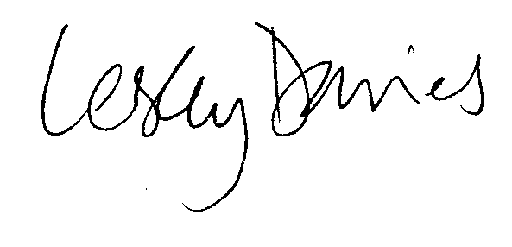
Lesley Davies
Director of Policy and Research

