2 July 2002

Ben Woodside
Strategy and Corporate Transactions Manager
Ofgem
9 Millbank
London
SW1P 3GE

Dear Mr. Woodside,

London Electricity Group's Proposed Acquisition of SEEBOARD

Thank you for the opportunity to comment on the issues raised in the above consultation dated June 2002.

Our main concern with LE's proposed acquisition of SEEBOARD is that it effectively removes the last independent supplier from the GB electricity market. This will further increase the extent of vertical integration in the GB electricity market, restricting the scope for competition in both wholesale and retail sectors. Unrestricted vertical integration like this, combined with long-term rigidities in the supply market, will prevent the full benefits of competition flowing to all consumers and may contribute to inefficient cross subsidies and distortion of wholesale and retail markets. Our concerns on this are detailed more fully in our response to Ofgem's consultation on the removal of the self-supply restrictions (copy attached).

We note that energywatch and other customer organisations have also expressed serious concerns regarding aspects of supply competition and the detrimental effects of vertical integration, especially with respect to the domestic sector of the market. This suggests that a full, comprehensive and independent review of structural and competition issues focusing on the supply market should be undertaken before major (probably irreversible) decisions are taken. We recognise that EU rules dictate that Brussels holds responsibility for competition clearance of this merger. However, it will still be possible for either Ofgem or the Secretary of State to refer the whole issue of market structure and whether current levels of vertical integration are or are not acting in consumers’ best interests to the Competition Commission. In our view the loss of the one remaining independent supplier is an appropriate trigger for such an investigation.

Finally, we have previously expressed our concerns regarding EdF's unfettered ability to take advantage of the liberalised energy markets within GB whilst its home market remains effectively foreclosed to reciprocal competition. The French Government's minimalist approach to implementation of the EC's electricity and gas directives together with its resistance to a meaningful single market for energy and choice for all consumers remains problematic. The result is a distorted European energy market which affects both energy consumers (who face considerable variations in levels of choice and price) and energy companies (for whom the degree of threat from competitors varies considerably). Given the Community dimension to this particular acquisition, we would therefore again urge Ofgem (via the OFT) to make representations in the strongest terms possible to the Commission with a view to securing meaningful concessions on market liberalisation.

Notwithstanding Ofgem’s view that the existing Self-Supply restrictions should be abandoned, we believe it would be a mistake for this acquisition to be cleared without comprehensive analysis of the the implications for market structure and competition. We note that all previous similar acquisitions have had conditions attached and we would urge the Secretary of State to give serious consideration to imposing further appropriate conditions on the London Electricity Group so as to mitigate the detrimental impacts of further vertical integration.

Given the wider implications of this proposed acquisition, I am copying our response to Joan MacNaughton at DTI.

Yours sincerely,

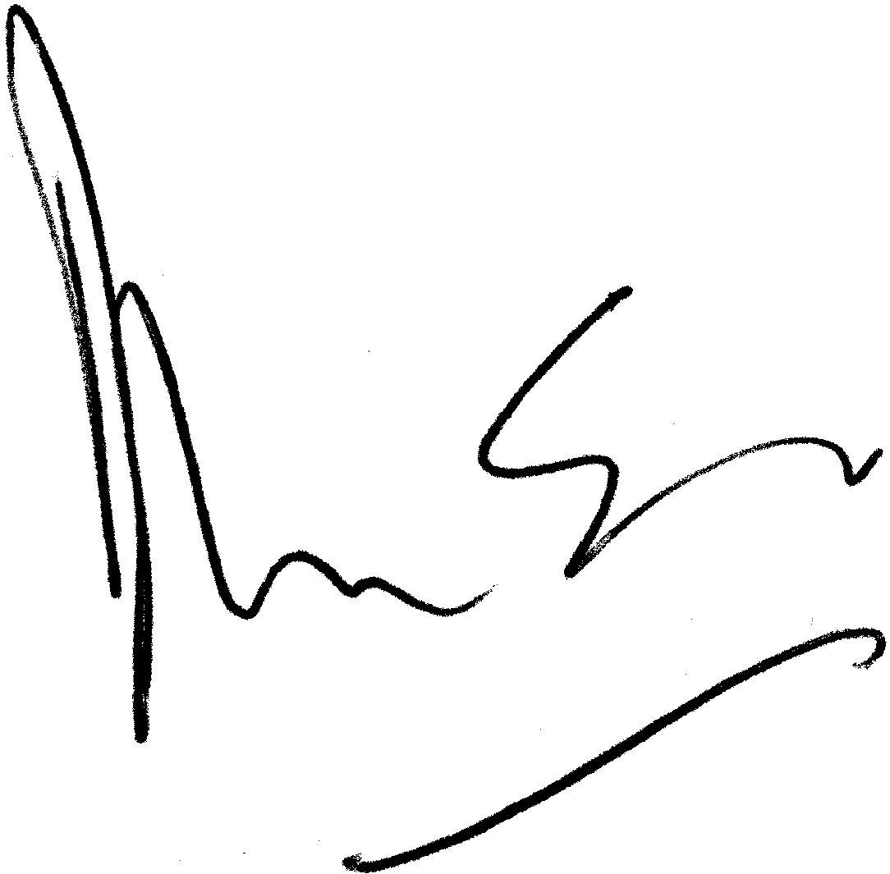

David Love
Head of Regulation

Direct Line: 01452 653325
Fax: 01452 653246
E-Mail: david.love@british-energy.com

