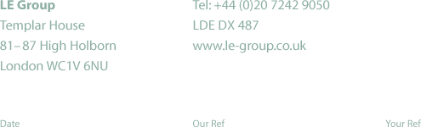

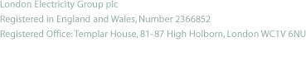
2nd April 2002 BNFLFellsideacquisition2

Lisa Vango,
Ofgem,
9 Millbank,
London,
SW1P 3GE.
Lisa.vango@ofgem.gov.uk

Dear Lisa,

LE Group response to the consultation on British Nuclear Fuels plc’s completed acquisition of Fellside Heat and Power Limited

LE Group welcomes the chance to comment on the above consultation and has the following point to make.

We do not think that the sale of Scottish and Southern Energy plc’s 50% shareholding in Fellside Heat and Power Limited to British Nuclear Fuels plc will be detrimental to the generation market in England and Wales. It will result in a negligible change (<1) to the Herfindahl-Hirschman Index whose current value of c. 960 indicates that the generation market is currently highly competitive.

Yours sincerely,

Liz Anderson
General Manager
Energy Strategy and Regulation

